SUPPLEMENTARY MATERIALS

Supplementary Figure 1. Individual criteria for comprehensive disease control over time in DE019. Percentages of patients treated with ADA + MTX or PBO + MTX achieving (A) LDA (DAS28[CRP] ≤3.2) or remission (DAS28[CRP] <2.6), (B) normal function (HAQ-DI <0.5), and (C) radiographic nonprogression (ΔmTSS ≤0.5) at weeks 24 and 52. Last observation carried forward for DAS28(CRP) and HAQ-DI; linear extrapolation for mTSS; nonresponder imputation for patients without any postbaseline DAS28(CRP), HAQ-DI, or mTSS.
ADA, adalimumab; DAS28(CRP), 28-joint Disease Activity Score based on C-reactive protein; HAQ-DI, Health Assessment Questionnaire Disability Index; IR, inadequate response; LDA, low disease activity; ΔmTSS, change in modified total Sharp score; MTX, methotrexate; PBO, placebo.
**P<0.01 and ***P<0.001 from generalized estimating equation or logistic regression, ADA + MTX vs PBO + MTX.

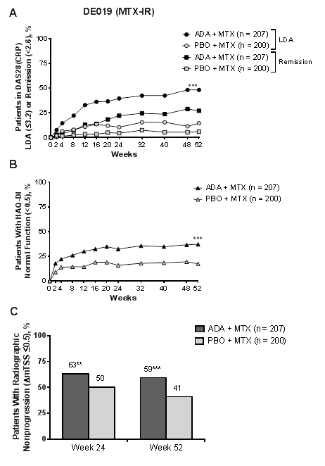
Supplementary Figure 2. Individual criteria for comprehensive disease control over time in PREMIER. Percentages of patients treated with ADA + MTX or PBO + MTX achieving (A) LDA (DAS28[CRP] ≤3.2) or remission (DAS28[CRP] <2.6), (B) normal function (HAQ-DI <0.5), and (C) radiographic nonprogression (ΔmTSS ≤0.5) at weeks 26 and 52. Last observation carried forward for DAS28(CRP) and HAQ-DI; linear extrapolation for mTSS; nonresponder imputation for patients without any postbaseline DAS28(CRP), HAQ-DI, or mTSS.
ADA, adalimumab; DAS28(CRP), 28-joint Disease Activity Score based on C-reactive protein;HAQ-DI, Health Assessment Questionnaire Disability Index; LDA, low disease activity; ΔmTSS, change in modified total Sharp score; MTX, methotrexate; PBO, placebo. **P<0.01 and ***P<0.001 from generalized estimating equation or logistic regression, ADA + MTX vs PBO + MTX. 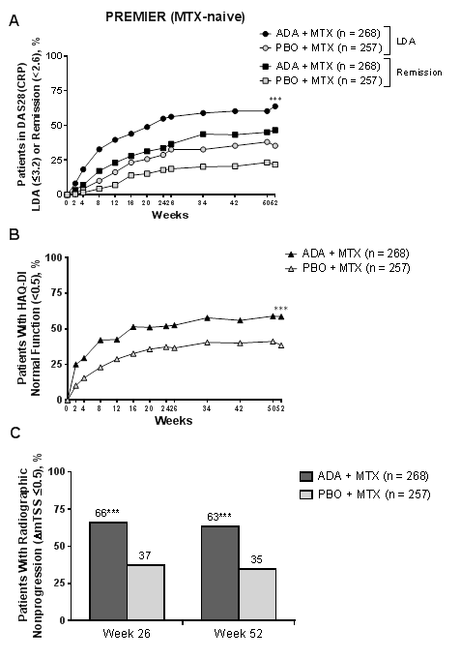

Supplementary Figure 3. Individual criteria for comprehensive disease control over time in the Rescue ADA arm of OPTIMA. Percentages of patients treated with ADA + MTX or PBO + MTX achieving (A) LDA (DAS28[CRP] ≤3.2) or remission (DAS28[CRP] <2.6), (B) normal function (HAQ-DI <0.5), and (C) radiographic nonprogression (ΔmTSS ≤0.5) at weeks 26 and 52. Last observation carried forward for DAS28(CRP) and HAQ-DI; linear extrapolation for mTSS; nonresponder imputation for patients without any postbaseline DAS28(CRP), HAQ-DI, or mTSS.
ADA, adalimumab; DAS28(CRP), 28-joint Disease Activity Score based on C-reactive protein; HAQ-DI, Health Assessment Questionnaire Disability Index; IR, inadequate response; LDA, low disease activity; ΔmTSS, change in modified total Sharp score; MTX, methotrexate; PBO, placebo.
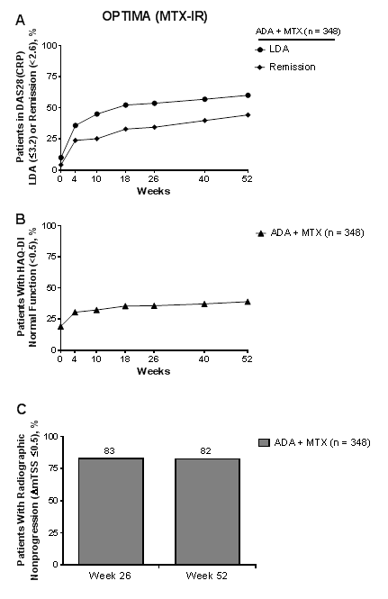

Supplementary Figure 4. Frequency of responders to each CDC criterion (DAS28[CRP] ≤3.2, low disease activity, HAQ-DI <0.5, and ΔmTSS ≤0.5) at week 52 based on study treatments (A) DE019, ADA + MTX; (B) DE019, PBO + MTX; (C) PREMIER, ADA + MTX; (D) PREMIER, PBO + MTX; and (E) OPTIMA, open-label ADA + MTX (Rescue ADA arm).
ADA, adalimumab; CDC, comprehensive disease control; DAS28(CRP), 28-joint Disease Activity Score based on C-reactive protein; HAQ-DI, Health Assessment Questionnaire Disability Index; IR, inadequate response; ΔmTSS, change in modified total Sharp score; MTX, methotrexate; PBO, placebo.
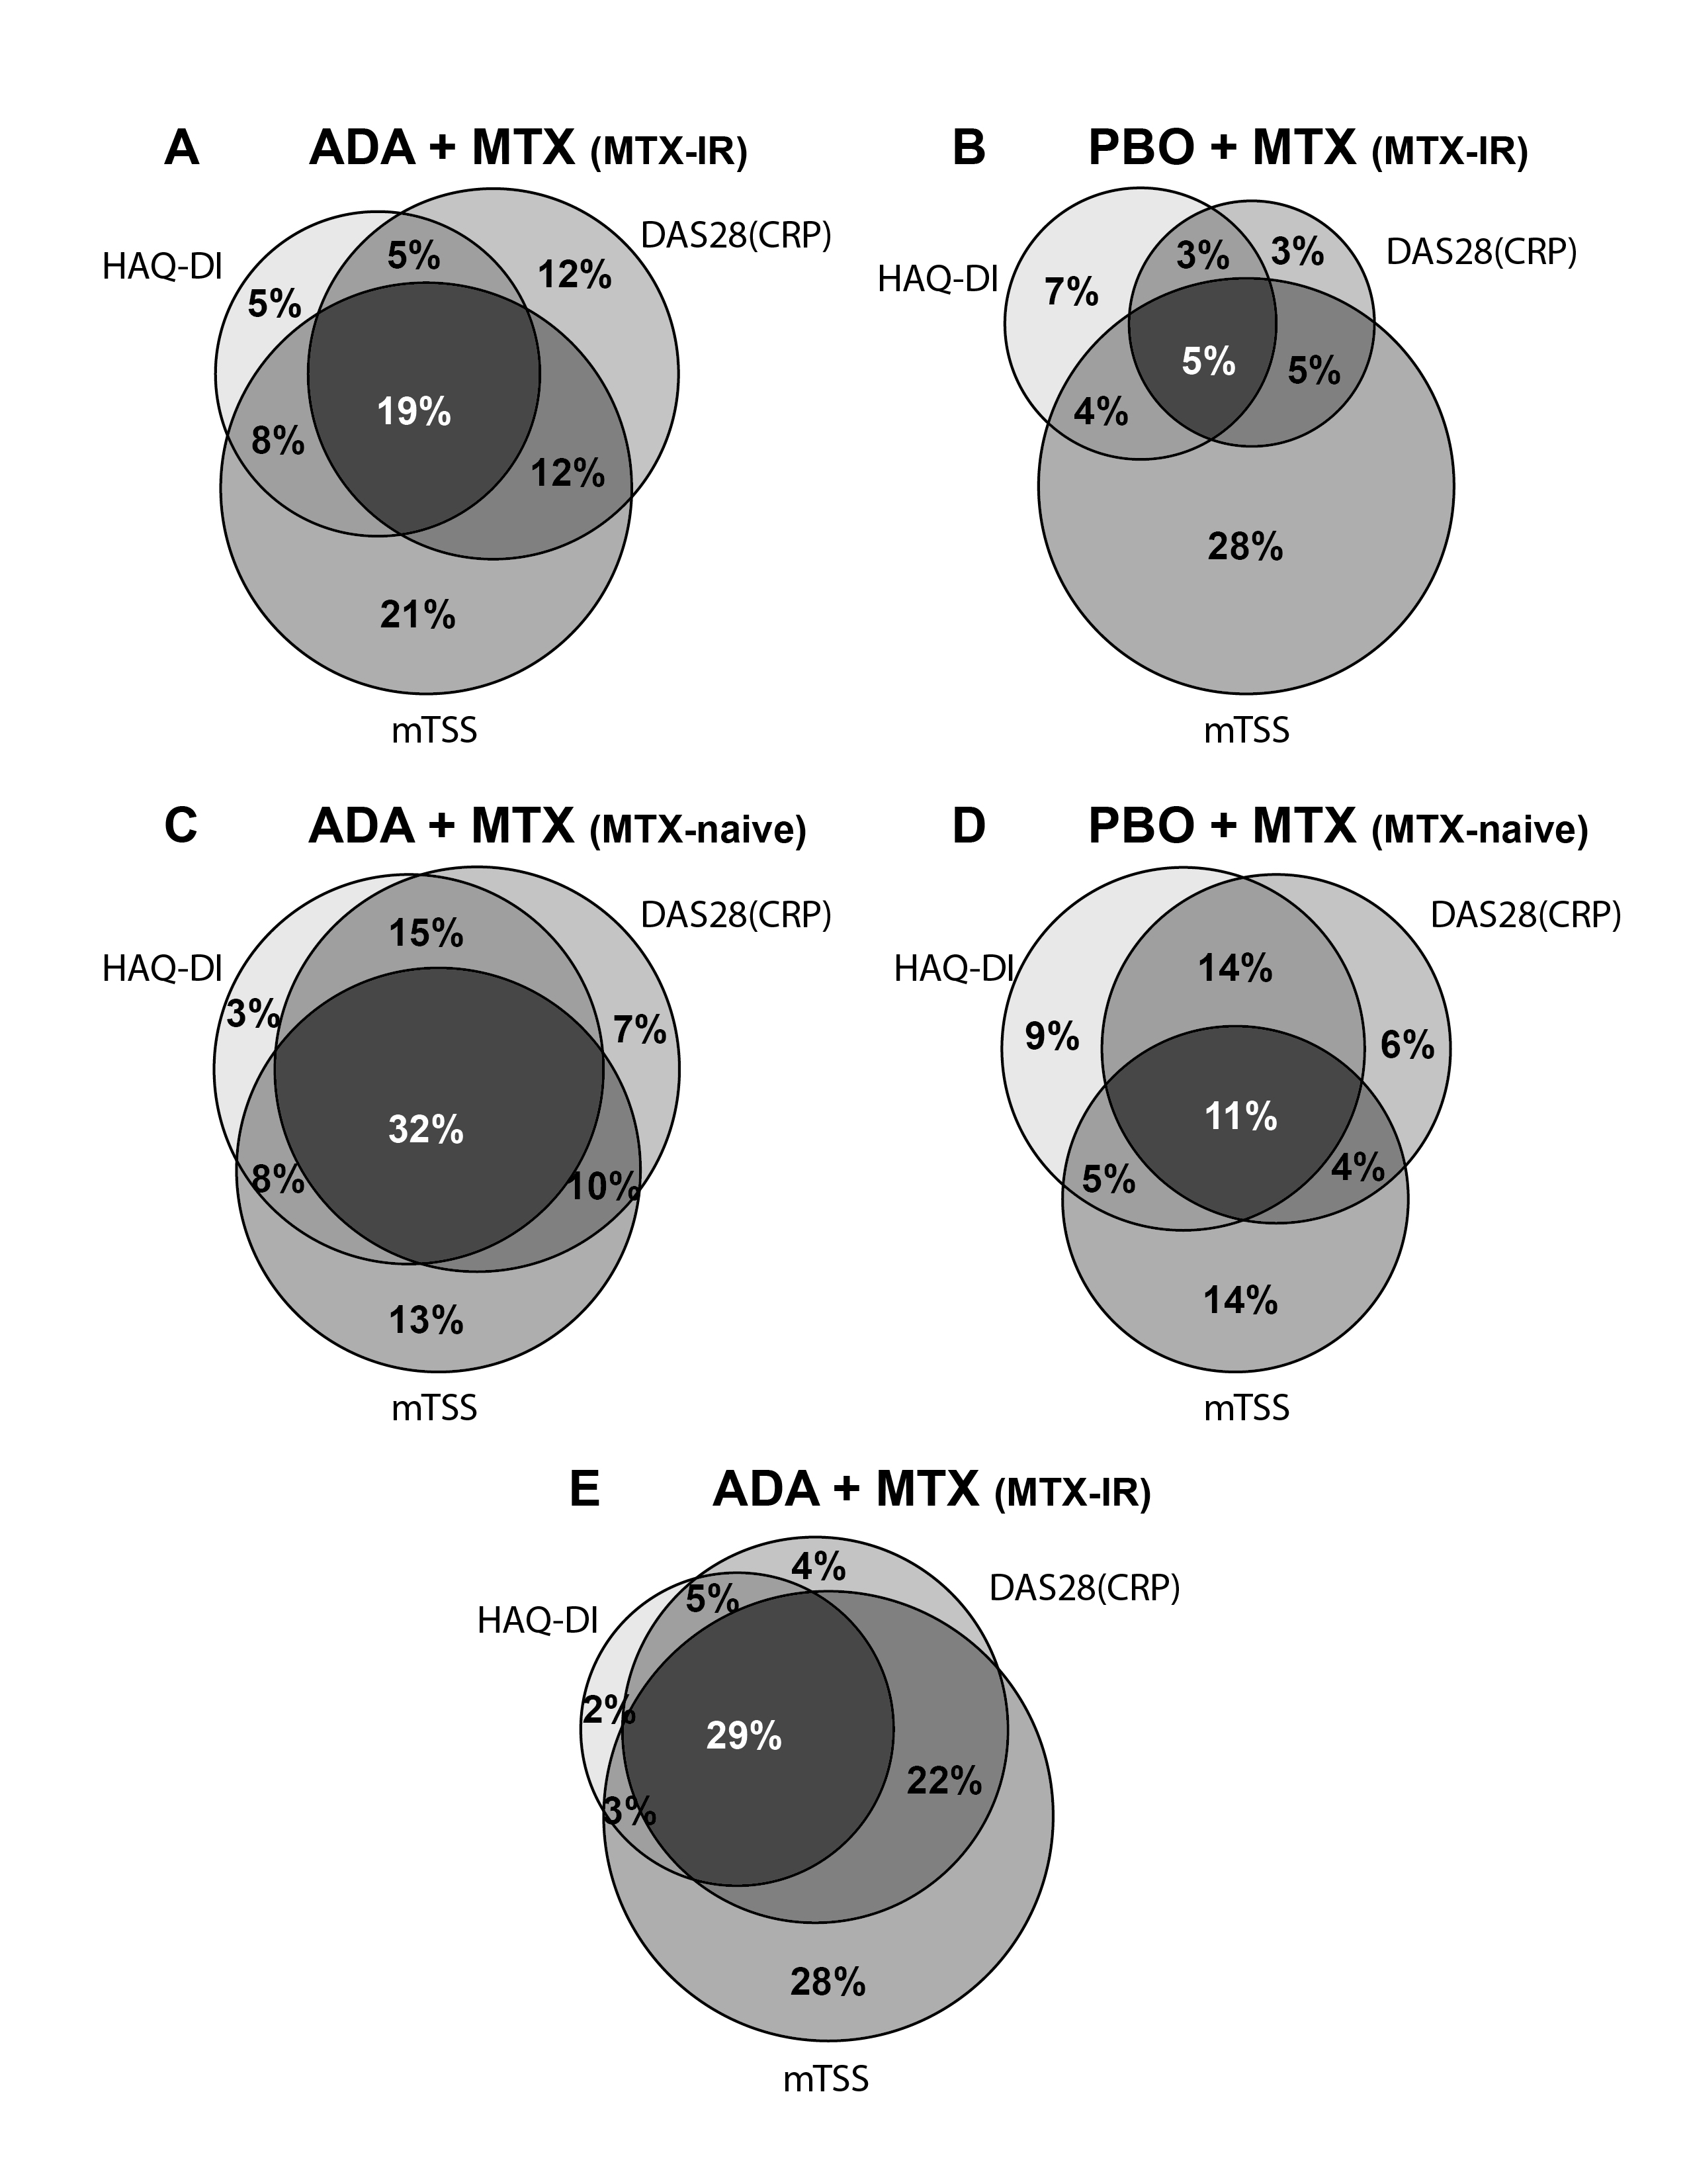

Supplementary Figure 5. Percentage of patients with established RA with DAS28(CRP) ≤3.2 at week 24 in DE019 who met criteria for CDC, clinical remission, nonprogression of joint damage, or normal physical function at week 52. The last observation carried forward imputation method was used for patients with missing DAS28(CRP) and HAQ-DI data. Linear extrapolation was conducted for patients with missing mTSS data. The nonresponder imputation method was used for patients without any postbaseline DAS28(CRP), HAQ-DI, or mTSS data.
ADA, adalimumab; CDC, comprehensive disease control; DAS28(CRP), 28-joint Disease Activity Score based on C-reactive protein; HAQ-DI, Health Assessment Questionnaire Disability Index; IR, inadequate response; ΔmTSS, change in modified total Sharp score; MTX, methotrexate; PBO, placebo; RA, rheumatoid arthritis.
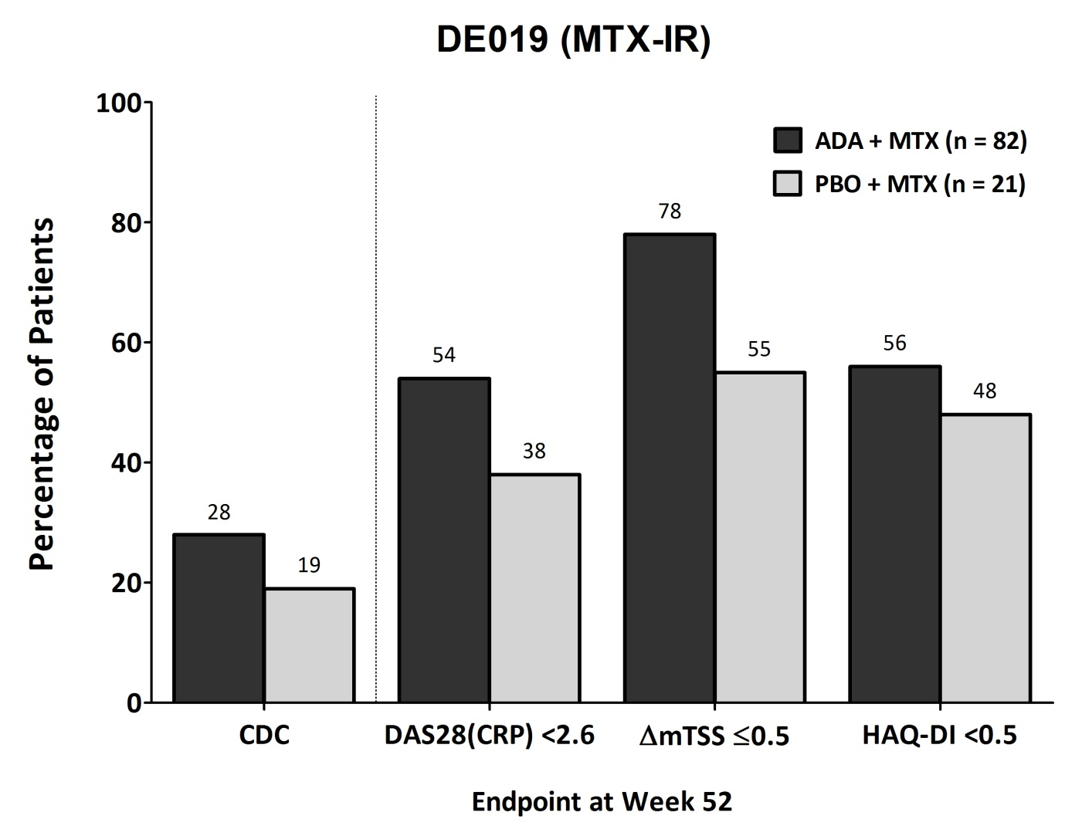

Supplementary Figure 6. Mean ΔmTSS from week 24/26 to week 52 in patients with established RA (DE019) or early RA (PREMIER and OPTIMA), assessed in patients in remission based on DAS28(CRP) or SDAI. Linear extrapolation was conducted for patients with missing mTSS data.
ADA, adalimumab; DAS28(CRP), 28-joint Disease Activity Score based on C-reactive protein; IR, inadequate response; ΔmTSS, change in modified total Sharp score; MTX, methotrexate; PBO, placebo; RA, rheumatoid arthritis; SDAI, Simplified Disease Activity Index.

