**SUPPLEMENTARY MATERIAL**

SAOL cohort

The SAOL (Santo António dos Olivais) study is a population-based cohort, designed to examine the association between a variety of potential risk factors and osteoporosis and fragility fractures. Design and recruitment have been previously described.[13-15] From March 1998 to April 2000, 1,745 persons, aged >18 years, were identified, contacted and recruited, with the method of random numbers selection from the electoral register of the county, stratified by gender and 5-year age strata. Participants responded to validated questionnaires on risk factors for osteoporosis and underwent a DXA examination of the lumbar spine and proximal femur. Between March 2011 and March 2014, a follow up visit was done by a research nurse, who applied the questionnaires also used at baseline and performed DXA examination.

IPR cohort

The population of this prospective cohort study consists of 819 women and men aged 40 years or older at baseline, of whom a DXA was performed between December 1999 and July 2001 at IPR (Instituto Português de Reumatologia, Lisbon). Participants responded to a dedicated questionnaire on risk factors for osteoporosis and fracture. There were no predefined criteria for ordering a DXA, the request being based solely on judgment of the responsible clinician. Participants were referred by physicians, including general practitioners, rheumatologists, endocrinologists, orthopedic surgeons, and gynaecologists. Participants were invited for a follow up visit which took place between September and December 2014 by a research nurse who applied a questionnaire about fractures and osteoporosis treatment..

EPIPorto cohort

The EPIPorto study is a population-based cohort study, with the aim of assessing determinants of health in the adult population of Porto. For this purpose, 2485 community-dwellers aged >18 years, selected in 1999-2003 by random digit phone dialing, have been repeatedly evaluated. Design and recruitment have been previously described.[16] The first evaluation did not include assessment of data on glucocorticoid intake and secondary osteoporosis. The second evaluation, performed in 2005-2006, including 1466 persons, recorded all clinical parameters relevant to FRAX®. We decided to use clinical parameters collected in the second evaluation, thus preferring to have a shorter follow up (mean average 7.43 years) than an incomplete set of predictors. No imputation was used for the missing follow-up time. Baseline DXA evaluation of 198 participants in this cohort was available.

A third follow up visit took place between June 2013 and December of 2014, performed by a well-trained research team and included a questionnaire, especially designed for the purposes of this study.

**Supplementary Figure 1. Disposition of participants in the three prospective cohort studies.**

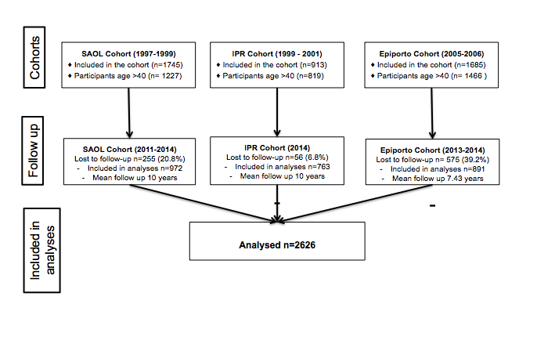

**Supplementary Table 1**. Baseline characteristics of participants with and without fracture including FRAX® risk estimates, there were no missing data for any of the clinical risk factors.

|  |  |  |  |
| --- | --- | --- | --- |
|  | **With fracture**  **(n=178)** | **Without fracture**  **(n=2,448)** | **p value** |
| Gender (Female), n (%) | 145 (81.5) | 1,798 (73.4) | <.01 |
| Age, mean (SD) | 62 (8.7) | 58 (10) | <.001 |
| 40-60, n (%) | 68 (38.2) | 1427 (58.3) | <.001 |
| 60-75, n (%) | 95 (53.4) | 855 (34.9) | <.001 |
| >75, n (%) | 15 (8.4) | 166 (6.8) | <.001 |
| BMI, n (%) | 26.9 (4.5) | 27.3 (4.4) | 0.22 |
| Previous Fracture, n (%) | 72 (40.4) | 440 (18.0) | <.001 |
| Parent Hip fractures, n (%) | 21 (11.8) | 170 (6.9) | <.001 |
| Current smoking, n (%) | 37 (20.8) | 575 (23.5) | 0.46 |
| Glucocorticoids, n (%) | 35 (19.7) | 147 (6.0) | <.001 |
| Rheumatoid arthritis, n (%) | 21 (11.8) | 107 (4.4) | <.001 |
| Secondary osteoporosis, n (%) | 66 (37.1) | 573 (23.4) | <.001 |
| Alcohol 3 or more units day, n (%) | 41 (23) | 488 (19.9) | 0.33 |
| Femoral Neck T Score, mean (SD) # | -2.31(1.1) | -1.48 (1.3) | <.001 |
| ≥ - 1, n (%) | 15 (10.8) | 580 (33) | <.001 |
| - 2,5 < T < -1, n (%) | 64 (46) | 803 (45.7) | <.001 |
| ≤ -2,5, n (%) | 60 (43.2) | 375 (21.3) | <.001 |
| Median 10-year probability, median (IQR) |  |  |  |
| MOP without BMD | 6.7 (3.9-10) | 2.7 (1.6-5.3) | <.001 |
| MOP with BMD | 8.9 (5.2-14.0) | 3.2 (1.8-6.2) | <.001 |
| HIP without BMD | 1.6 (0.7-3.9) | 0.5 (0.2-1.5) | <.001 |
| HIP with BMD | 2.8 (1.0 -6.8) | 0.6 (0.2-2.1) | <.001 |

# Femoral Neck BMD was available for 1897 participants.

**Supplementary Figure 2**. Comparison of ROC curves for 10-year probability of a major osteoporotic fracture (both genders) estimated by FRAX® with and without BMD and for DXA alone.



**Supplementary Figure 3.** Comparison of ROC curves for 10-year probability of hip fracture (both genders) estimate by FRAX® with and without BMD and for DXA alone.

