Supplementary File

As requested by the reviewer we have added in the Supplementary file the forest plots for the different OA localizations.

Knee OA:
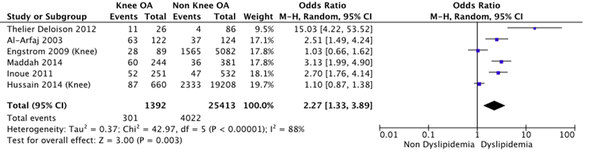

Hip OA:
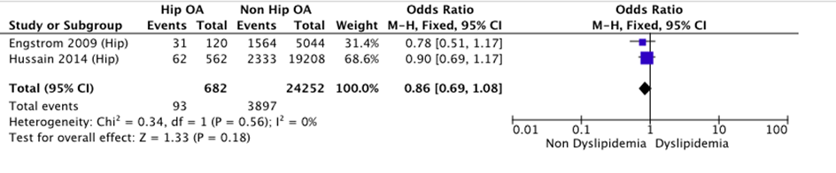
Hand OA:
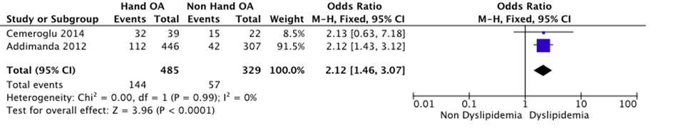

As requested by the reviewer we have added in the Supplementary file the funnel plot.
