Supplementary 4

Fatigue, 1 year

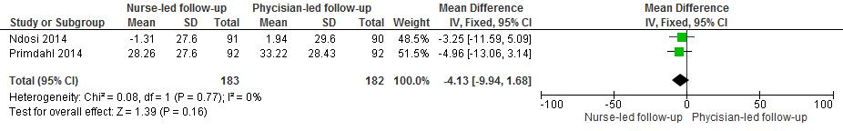
Fatigue 2 year
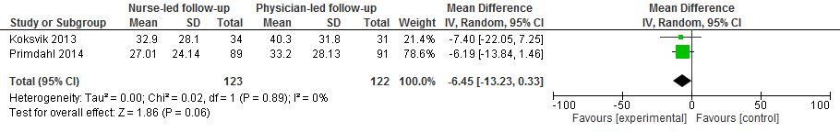

Physical disability 1 year
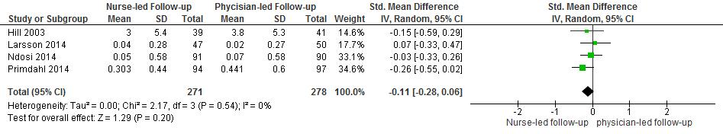
Physical disability 2 year

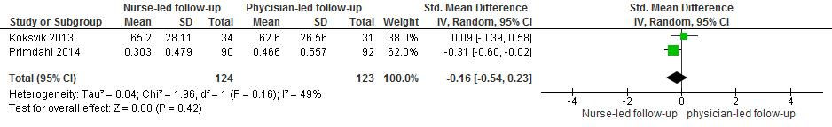

Quality of life, 1 year
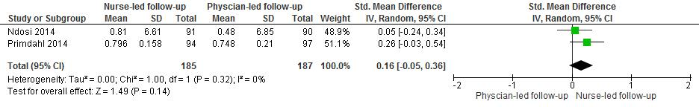
Quality of life, 2 year
