SUPPLEMENTARY FILE

TITLE
Response to Baricitinib Therapy in Rheumatoid Arthritis Patients with Inadequate Response to csDMARDs as a Function of Baseline Characteristics

AUTHORS
Joel M. Kremer¹, Michael Schiff², David Muram³, Jinglin Zhong⁴, Jahangir Alam³, Mark C. Genovese⁵

Supplementary figures
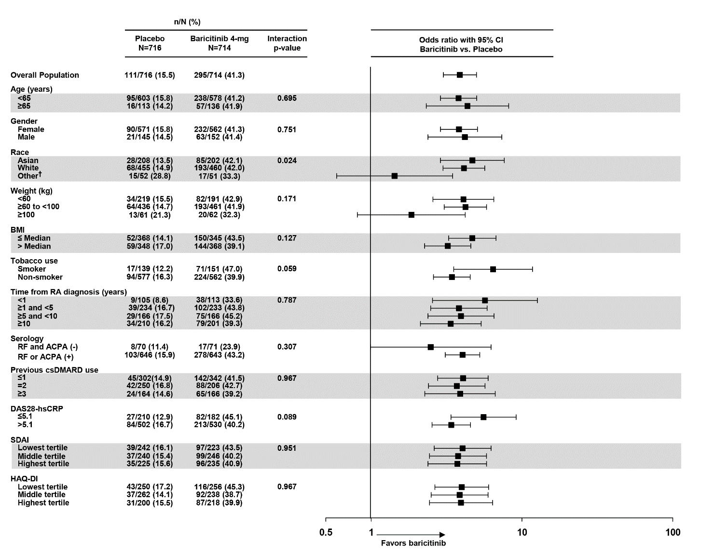
Supplementary Figure 1. Percentage of patients achieving 50% improvement in American College of Rheumatology criteria at Week 12 by patient demographic and disease characteristics subgroups. Data (nonresponder imputation) are presented as n/N (%). ACPA=anti-citrullinated peptide antibody; BMI=body mass index; CI=confidence interval; csDMARD=conventional synthetic disease-modifying anti-rheumatic drug; DAS28-hsCRP= Disease Activity Score for 28 joint counts based on the level of high-sensitivity C-reactive protein; HAQ-DI=Health Assessment Questionnaire-Disability Index; N=number of mITT patients in the specified treatment population; n=number of patients in specified category; RA=rheumatoid arthritis; RF=rheumatoid factor; SDAI=Simplified Disease Activity Index.
†When logistic regression sample size requirements were not met, Cochran-Mantel-Haenszel test stratified by study was applied.
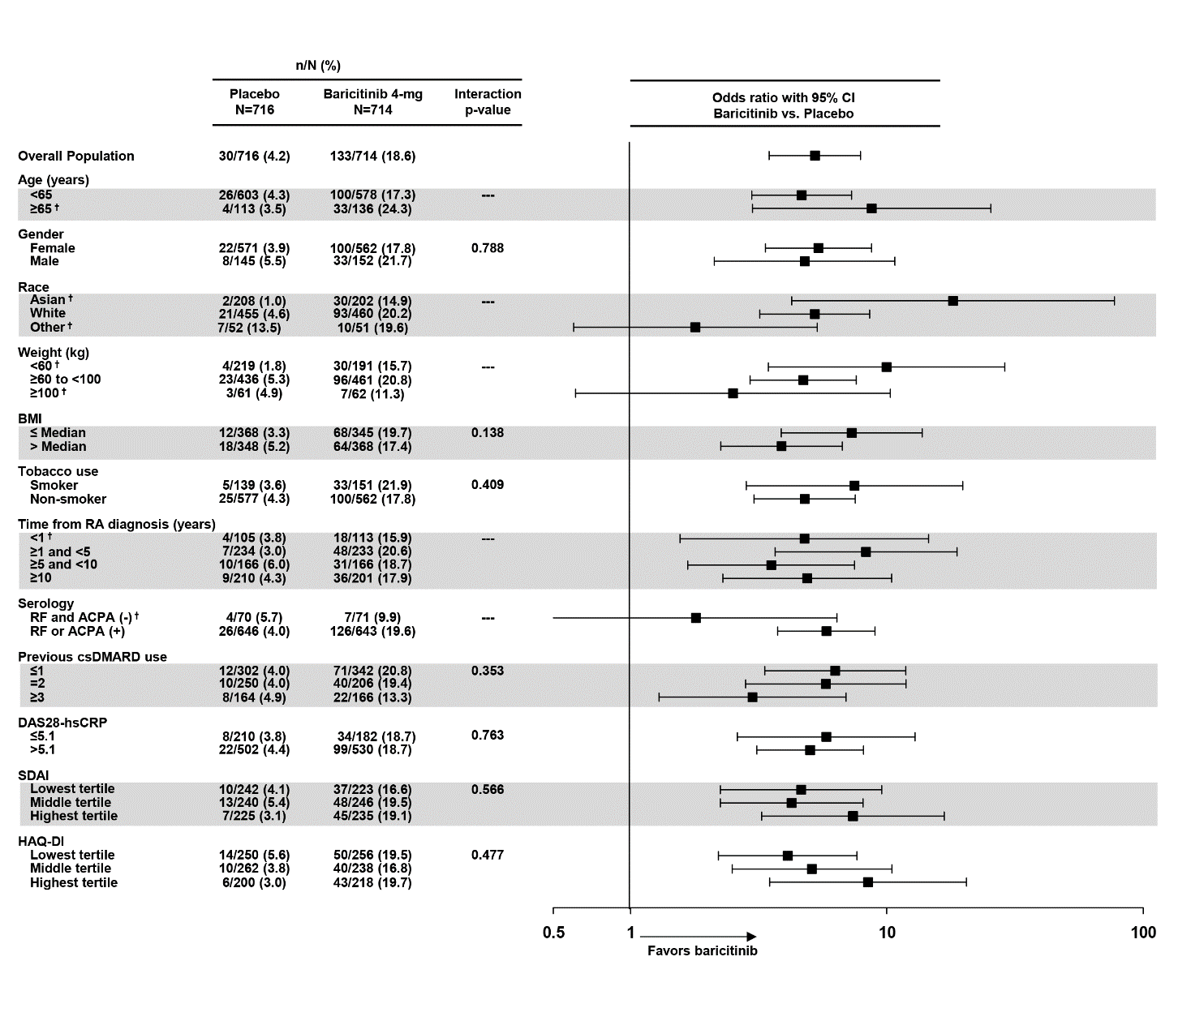
Supplementary Figure 2. Percentage of patients achieving 70% improvement in American College of Rheumatology criteria at Week 12 by patient demographic and clinical characteristics subgroups. Data (nonresponder imputation) are presented as n/N (%) patients. ACPA=anti-citrullinated peptide antibody; BMI=body mass index; CI=confidence interval; csDMARD=conventional synthetic disease-modifying anti-rheumatic drug; DAS28-hsCRP= Disease Activity Score for 28 joint counts based on the level of high-sensitivity C-reactive protein; HAQ-DI=Health Assessment Questionnaire-Disability Index; N=number of mITT patients in the specified treatment population; n=number of patients in specified category; RA=rheumatoid arthritis; RF=rheumatoid factor; SDAI=Simplified Disease Activity Index.
†When logistic regression sample size requirements were not met, Cochran-Mantel-Haenszel test stratified by study was applied.

