Supplemental Materials
Figure Legends
Supplemental Figure 1. Time to first methotrexate use during the OLE for year 2 LDA responders. LDA = low disease activity; MTX = methotrexate; OLE = open-label extension. *Censored (+) represents patients who either discontinued from the study or were ongoing at OLE year 3 (year 5 of study) without taking MTX. †Represents the numbers of patients who never received MTX during the OLE at the indicated time point.

Supplemental Figure 2. Association of disease parameters at the time of methotrexate reinitiation during the OLE based on propensity score matching. (A) Mean values for the indicated disease parameters at the time of MTX reinitiation (MTX use) versus matched controls (MTX non-use); (B) odds ratios (95% CIs) of MTX reinitiation for the indicated disease parameters. CRP = C-reactive protein; MTX = methotrexate; OLE = open-label extension; PGA = Physician Global Assessment; PtGA = Patient Global Assessment; SJC66 = swollen joint count based on 66 joints; TJC68 = tender joint count based on 68 joints.*4 of 30 MTX-use patients had no matches so total cases=26.

Supplemental Figure 1
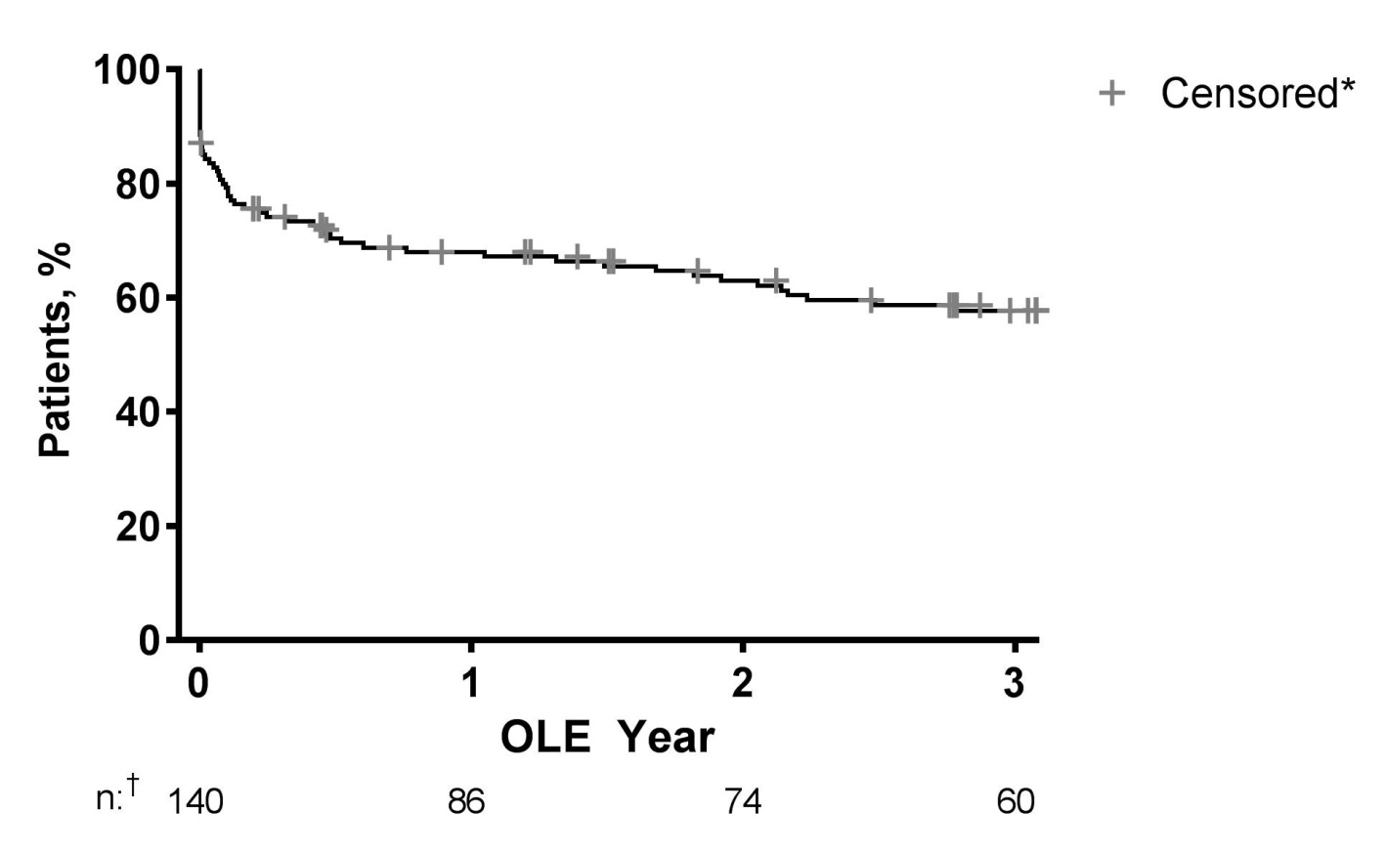

Supplemental Figure 2
