Supplementary Tables/Figures

Table S1. Radiographic Endpoints
Endpoints | Week 52 |  |  |  | Week 104
 | Placebo to sirukumab 50 mg q4w (n=203) | Placebo to sirukumab 100 mg q2w (n=203) | Sirukumab 50 mg q4w (n=419) | Sirukumab 100 mg q2w (n=444) | Placebo to sirukumab 50 mg q4w (n=194) | Placebo to sirukumab 100 mg q2w (n=186) | Sirukumab 50 mg q4w (n=384) | Sirukumab 100 mg q2w (n=412)
SHS, mean (SD) change from baseline | 3.20 (6.78) | 3.51 (9.80) | 0.56 (2.79) | 0.31 (3.22) | 3.79 (8.15) | 3.37 (12.28) | 1.23 (4.45) | 0.76 (3.88)
SHS, mean (SD) change from Week 52 to 104ª | – | – | – | – | 0.48 (3.65) | 0.28 (4.79) | 0.70 (2.72) | 0.43 (2.32)
Erosion score, mean (SD) change from baseline | 1.68 (3.81) | 1.86 (5.83) | 0.14 (1.91) | −0.17 (2.19) | 1.85 (4.71) | 1.49 (6.39) | 0.37 (2.85) | −0.05 (2.46)
JSN score, mean (SD) change from baseline | 1.52 (3.70) | 1.65 (4.40) | 0.42 (1.55) | 0.48 (1.77) | 1.94 (4.34) | 1.88 (6.27) | 0.86 (2.47) | 0.82 (2.50)
Proportions of patients, n (%), with radiographic progression^{b} | 63 (31.0) | 59 (29.1) | 55 (13.1) | 44 (9.9) | 51 (26.3) | 37 (19.9) | 55 (14.3) | 43 (10.4)
Proportions of patients, n (%), with change of ≤0 from baseline in SHS | 79 (38.9) | 77 (37.9) | 244 (58.2) | 278 (62.6) | 79 (40.7) | 68 (36.6) | 196 (51.0) | 234 (56.8)
q4w, every 4 weeks; q2w, every 2 weeks; SHS, modified Sharp/van der Heijde score; SD, standard deviation; JSN, joint space narrowing; SDC, smallest detectable change.
ªScore was based on observed data from Read Campaign 2.
^{b}SDC for change from baseline in SHS at Week 52=2.82 and Week 104=3.61.

Table S2. Mean (SD) Changes in SHS, Erosion, and JSN Scores
 | Met EE criteria |  | Crossed over at Week 52 |  | Sirukumab  50 mg q4w | Sirukumab  100 mg q2w
Mean (SD) changes | Placebo to sirukumab  50 mg q4w | Placebo to sirukumab  100 mg q2w | Placebo to sirukumab  50 mg q4w | Placebo to  sirukumab  100 mg q2w
Change from baseline to Week 52 | (n=73) | (n=73) | (n=120) | (n=118) | (n=419) | (n=444)
SHS | 2.29 (4.39) | 2.56 (6.43) | 3.73 (7.99) | 4.14 (11.61) | 0.56 (2.79) | 0.31 (3.22)
Erosion score | 1.17 (2.41) | 1.19 (3.83) | 1.94 (4.49) | 2.29 (6.90) | 0.14 (1.91) | −0.17 (2.19)
JSN score | 1.12 (2.62) | 1.37 (3.24) | 1.79 (4.32) | 1.85 (5.10) | 0.42 (1.55) | 0.48 (1.77)
Change from baseline to Week 104 | (n=72) | (n=69) | (n=112) | (n=107) | (n=384) | (n=412)
SHS | 2.78 (5.51) | 2.85 (7.55) | 4.42 (9.48) | 3.68 (14.77) | 1.23 (4.45) | 0.76 (3.88)
Erosion score | 1.27 (3.20) | 1.22 (4.02) | 2.17 (5.51) | 1.63 (7.69) | 0.37 (2.85) | −0.05 (2.46)
JSN score | 1.51 (3.29) | 1.63 (4.11) | 2.26 (4.91) | 2.04 (7.43) | 0.86 (2.47) | 0.82 (2.50)
Change from Week 52 to Week 104 | (n=72) | (n=69) | (n=112) | (n=107) | (n=384) | (n=412)
SHS | 0.47 (2.07) | 0.78 (4.50) | 0.49 (4.19) | −0.06 (5.12) | 0.70 (2.72) | 0.43 (2.32)
Erosion score | 0.09 (1.41) | 0.39 (2.60) | 0.10 (3.12) | −0.38 (2.50) | 0.24 (1.65) | 0.10 (1.32)
JSN score | 0.38 (1.58) | 0.39 (2.35) | 0.39 (1.40) | 0.32 (3.11) | 0.46 (1.54) | 0.34 (1.51)
SD, standard deviation; SHS, modified Sharp/van der Heijde score; JSN, joint space narrowing; EE, early escape; q4w, every 4 weeks; q2w, every 2 weeks.

Table S3. Proportion of Patients With a Change of ≤0 in SHS
Proportion of patients with a change of ≤0, n (%) | Met EE criteria |  | Crossed over at Week 52 |  | Sirukumab  50 mg q4w | Sirukumab  100 mg q2w
 | Placebo to sirukumab  50 mg q4w | Placebo to sirukumab  100 mg q2w | Placebo to sirukumab  50 mg q4w | Placebo to sirukumab  100 mg q2w
Baseline to Week 52ª | 30 (41.1) | 32 (43.8) | 46 (38.3) | 40 (33.9) | 244 (58.2) | 278 (62.6)
Baseline to Week 104^{b} | 30 (41.7) | 27 (39.1) | 45 (40.2) | 37 (34.6) | 196 (51.0) | 234 (56.8)
Change from Week 52 to 104^{b} | 49 (68.1) | 43 (62.3) | 74 (66.1) | 71 (66.4) | 219 (57.0) | 256 (62.1)
SHS, modified Sharp/van der Heijde score; EE, early escape; q4w, every 4 weeks; q2w, every 2 weeks.
ªMet EE criteria: placebo to sirukumab 50 mg q4w, n=73; placebo to sirukumab 100 mg q2w, n=73. Crossed over at Week 52: placebo to sirukumab 50 mg q4w, n=120; placebo to sirukumab 100 mg q2w, n=118. Sirukumab 50 mg q4w, n=419; sirukumab 100 mg q2w, n=444.
^{b}Met EE criteria: placebo to sirukumab 50 mg q4w, n=72; placebo to sirukumab 100 mg q2w, n=69. Crossed over at Week 52: placebo to sirukumab 50 mg q4w, n=112; placebo to sirukumab 100 mg q2w, n=107. Sirukumab 50 mg q4w, n=384; sirukumab 100 mg q2w, n=412.

Table S4. Number of Patients With NCI-CTCAE toxicity Grades 3 and 4 Postbaseline Laboratory Abnormalities Through Week 120
 | Placebo  (n=556) | Sirukumab
NCI-CTCAE Toxicity Grades 3 and 4 Abnormalities, n (%) |  | 50 mg q4w combined  (n=798) | 100 mg q2w combined  (n=799) | Overall  (n=1,597)
ALT (increased)  N  Grade 3 (>5-20 × ULN)  Grade 4 (>20 × ULN) | 551  4 (0.7)  2 (0.4) | 793  22 (2.8)  0 | 798  33 (4.1)  0 | 1,591  55 (3.5)  0
AST (increased)  N  Grade 3 (>5-20 × ULN)  Grade 4 (>20 × ULN) | 551  5 (0.9)  0 | 793  5 (0.6)  0 | 798  12 (1.5)  0 | 1,591  17 (1.1)  0
Cholesterol (increased)  N  Grade 3 (>10.36-12.95 mmol/L)  Grade 4 (>12.95 mmol/L) | 544  0  0 | 784  9 (1.1)  2 (0.3) | 791  14 (1.8)  0 | 1,575  23 (1.5)  2 (0.1)
Triglycerides (increased)  N  Grade 3 (>5.65-11.30 mmol/L)  Grade 4 (>11.30 mmol/L) | 544  8 (1.5)  0 | 784  29 (3.7)  1 (0.1) | 791  35 (4.4)  3 (0.4) | 1,575  64 (4.1)  4 (0.3)
Neutrophils (segmented decreased)  N  Grade 3 (<1-0.5 × 10⁹/L)  Grade 4 (<0.5 × 10⁹/L) | 551  3 (0.5)  1 (0.2) | 793  41 (5.2)  6 (0.8) | 798  34 (4.3)  1 (0.1) | 1,591  75 (4.7)  7 (0.4)
Platelets (decreased)  N  Grade 3 (<50-25 × 10⁹/L)  Grade 4 (<25 × 10⁹/L) | 550  0  0 | 793  1 (0.1)  0 | 798  1 (0.1)  0 | 1,591  2 (0.1)  0
Hemoglobin (decreased)  N  Grade 3 (<80 g/L)  Grade 4 (N/A)ª | 551  2 (0.4)  0 | 793  4 (0.5)  0 | 798  1 (0.1)  0 | 1,591  5 (0.3)  0
NCI-CTCAE, National Cancer Institute Common Terminology Criteria for Adverse Events; q4w, every 4 weeks; q2w, every 2 weeks; ALT, alanine aminotransferase; ULN, upper limit of normal; AST, aspartate aminotransferase; N/A, not applicable.
ªLife-threatening consequence; urgent intervention indicated.
Figure S1. Study Design
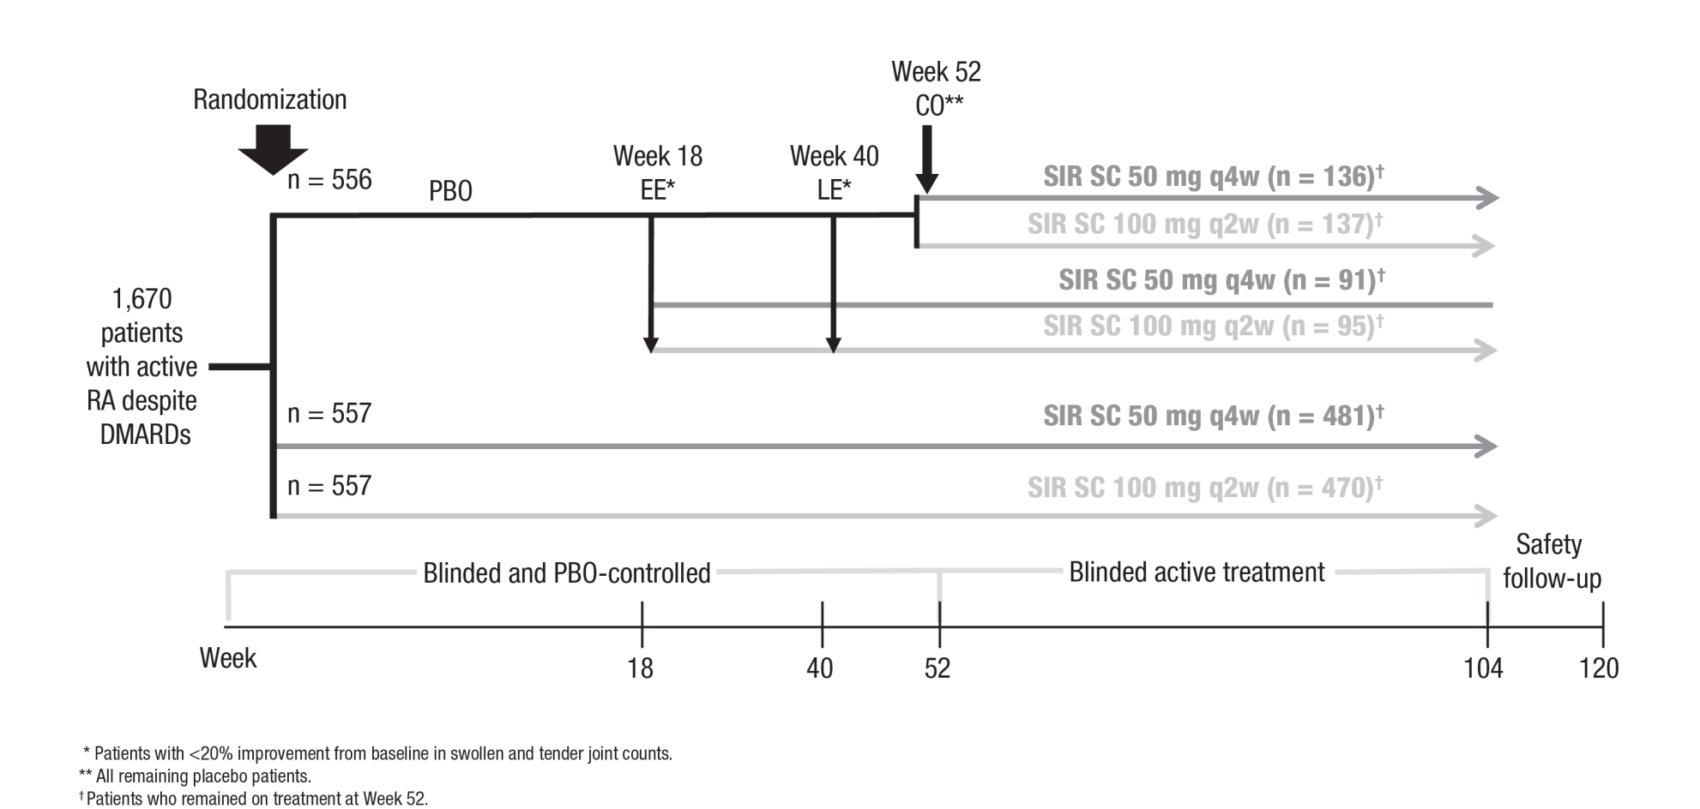

RA, rheumatoid arthritis; DMARD, disease-modifying antirheumatic drug; PBO, placebo; EE, early escape; LE, late escape; CO, crossover; SIR, sirukumab; SC, subcutaneous; q4w, every 4 weeks; q2w, every 2 weeks;.
A total of 1,402 patients remained on study treatment at Week 52 and were included in the active-controlled efficacy population (Week 52 to 104). 1 patient in the placebo group crossed over to sirukumab 50 mg q4w at Week 52 but never received active drug and was not included in the efficacy full analysis set. 5 patients in the sirukumab 50 mg q4w who remained on study treatment at Week 52 were not included in the efficacy full analysis set. 2 patients in the sirukumab 100 mg q2w group who remained on study treatment at Week 52 were not included in the efficacy full analysis set.
Figure S2. Patient Disposition
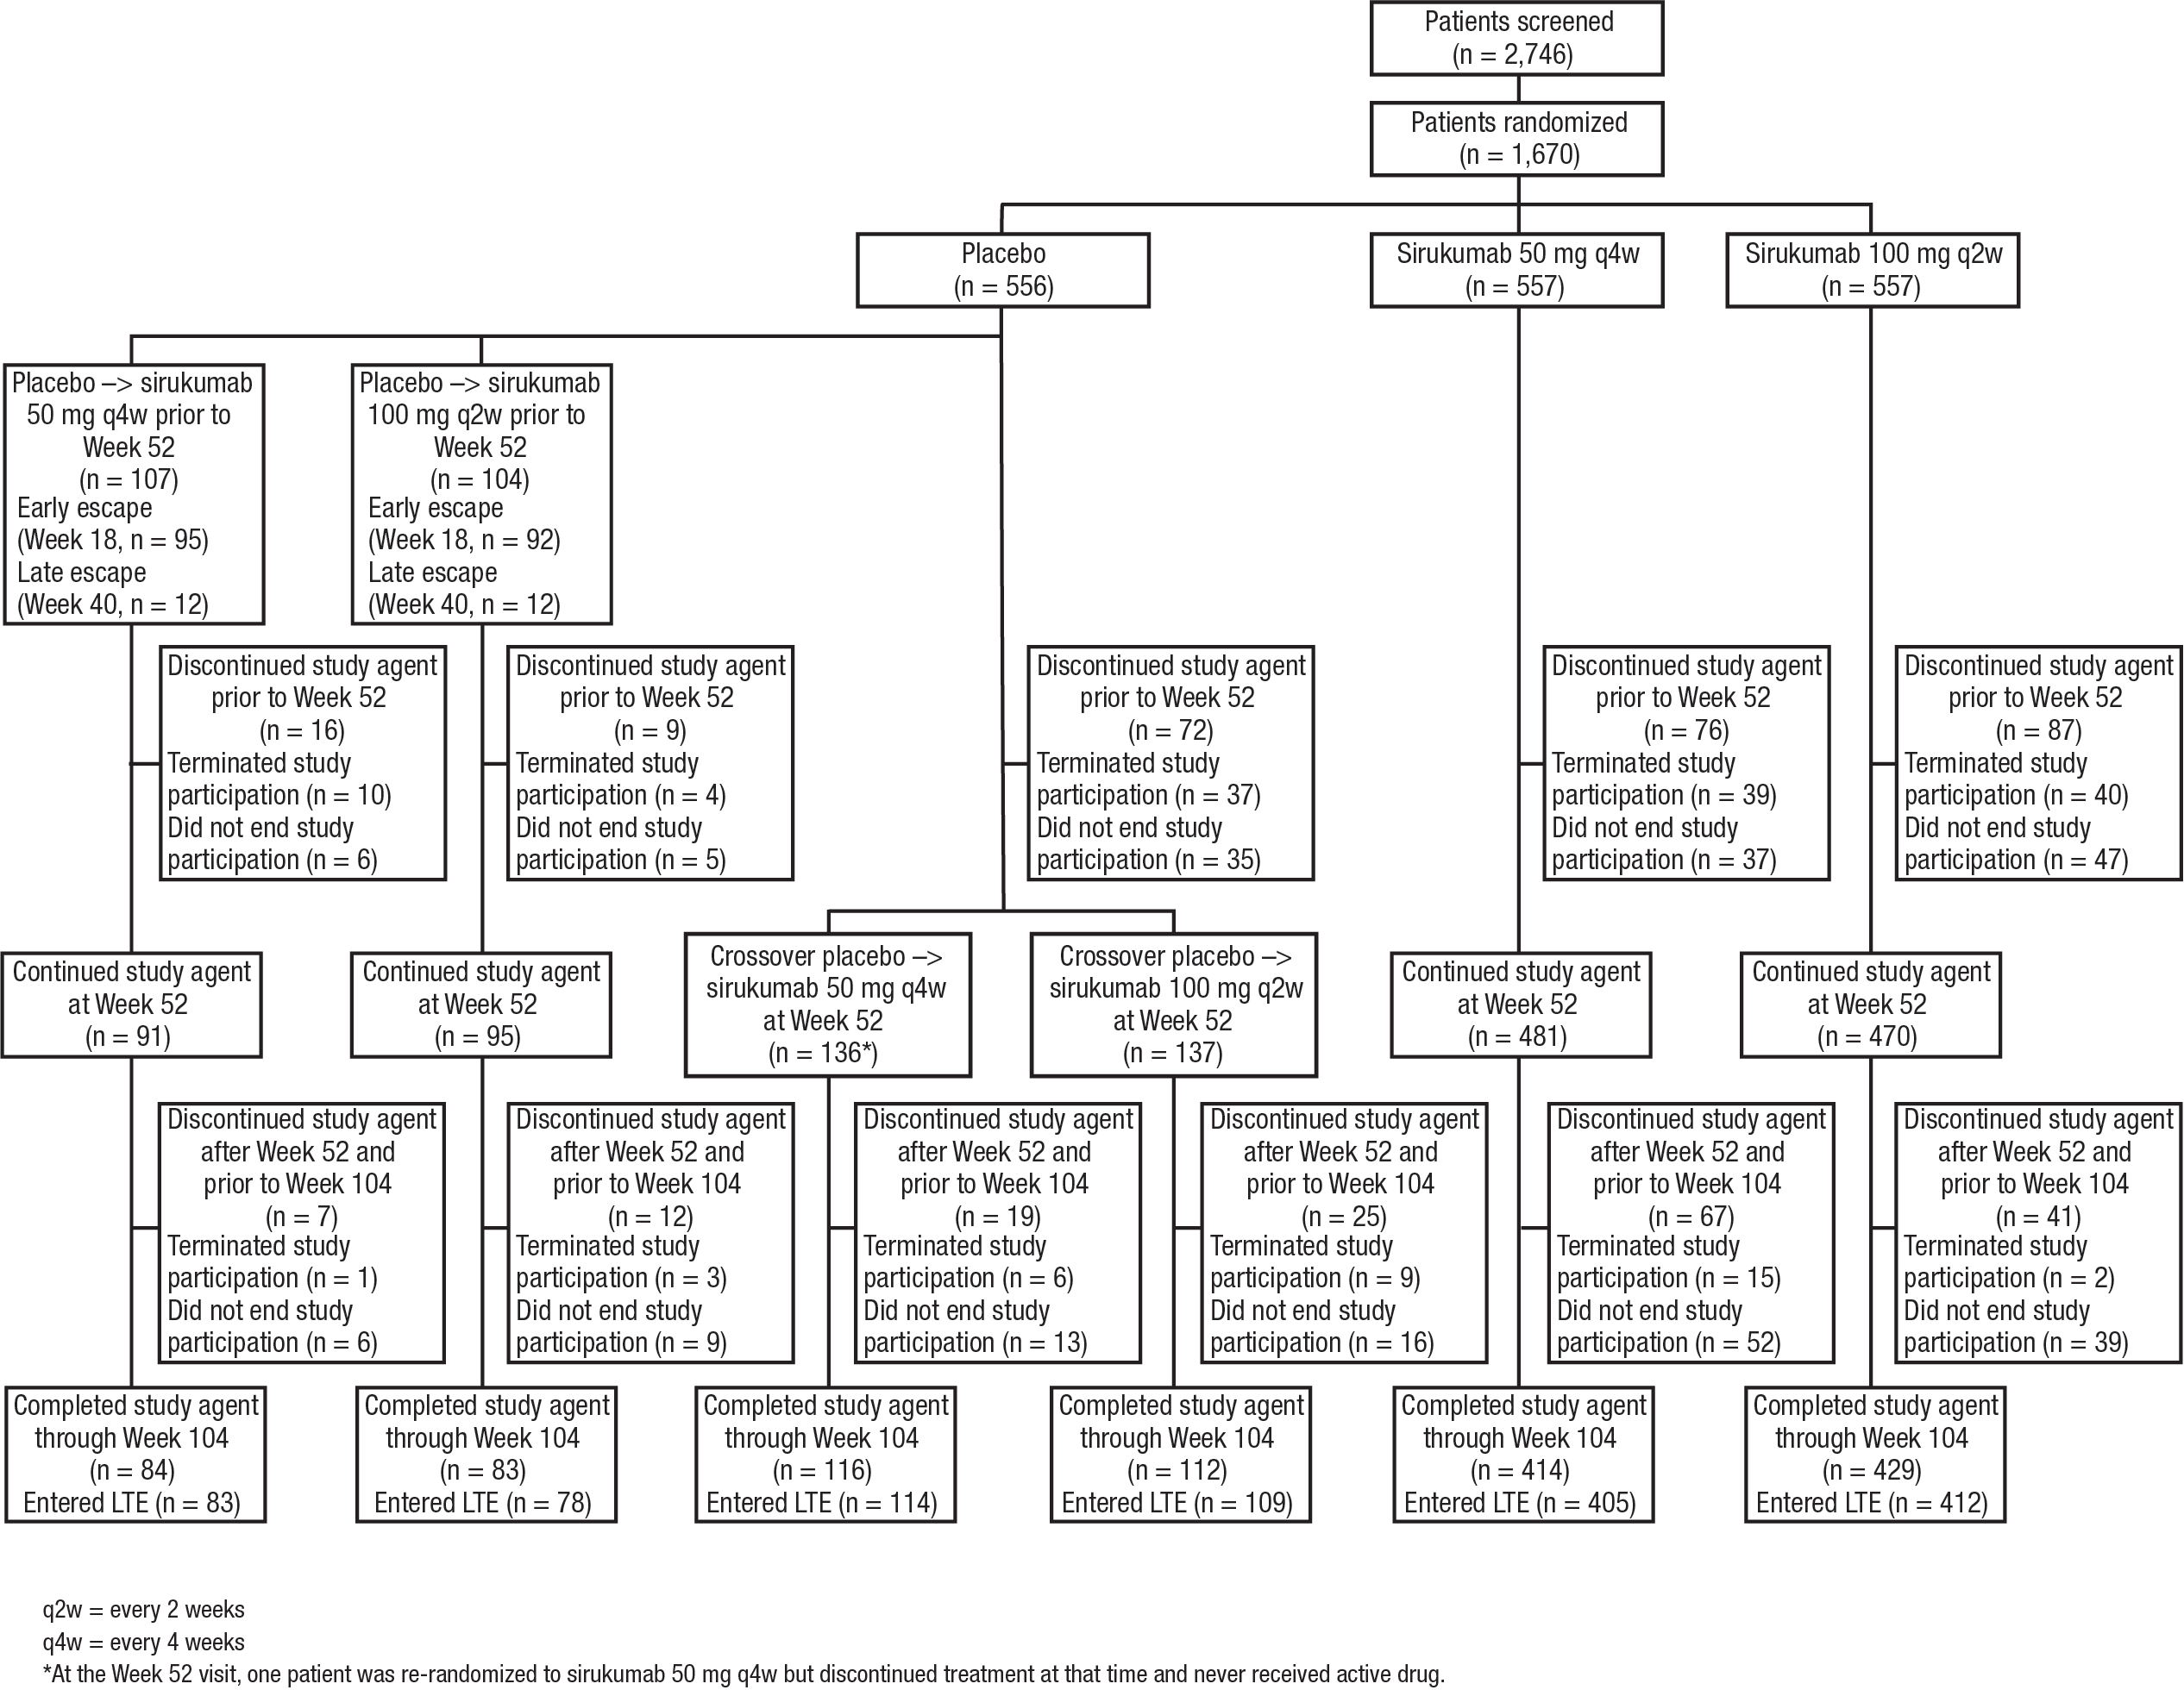
LTE, long-term extension.

