Table S1: Responding countries and the number of medical schools from each country
Country | Number of schools
Spain | 4
Italy | 4
Germany | 3
United Kingdom | 3
Portugal | 1
Switzerland | 1
France | 1
The Netherlands | 1
Hungary | 1
Poland | 1
Czech Republic | 1

Table S2: Teaching on RMDs history and examination
Topic | Number of schools
Inspection, palpation, and examination of movements | 18
Gait-arm-leg-screen (GALS) | 14
Description of the main phases of gait | 8
Identification of specific gaits
Spastic | 13
Antalgic | 12
Trendelenburg | 11
Parkinsonian | 10
Identification of disability and participation restriction | 11
Hyperalgesic tender sites for fibromyalgia | 16
Screening assessment for hypermobility (Beighton’s score) | 7
Cutaneous involvement in systemic sclerosis | 20

Table S3: Principles of management of RMDs
Topic | Number of schools
Core non-pharmacological interventions
Heat/cold packs | 17
Splinting | 14
TENS | 10
Exercise | 17
Lifestyle interventions | 18
Weight loss | 19
Factors influencing adherence to management | 13
Outline of coping strategies | 13
Pharmacologic interventions
Analgesics | 18
World Health Organisation pain ladder | 9
Outline of the indication for epidural analgesia | 6
Method of action, indications, contra-indications, side-effects:
Glucocorticoids | 18
DMARDs and biological agents | 20
Urate lowering treatment | 21
Neuro-pharmaceuticals e.g. low dose amitriptyline | 1
Nutraceuticals and alternative medicines | 8
Surgical
Total joint replacement | 17
Soft tissue surgery | 14
Tendon transfers | 6
Osteotomy | 8
Soft tissue release | 9
Orthoses, mobility aids and aids for daily living | 15
Assistive technology | 13
Multidisciplinary team | 13

Table S4: Curriculum content on neck and low back pain
Topic | Number of schools
Mechanical | 20
Inflammatory | 20
Destructive | 19
Crush fracture related | 18
Red-flag signs/symptoms* | 19
Spinal stenosis | 19
Radiculopathy | 19
Spondylolysis | 14
Spondylolisthesis | 13
*should lead to investigation for serious pathology

Table S5: Curriculum content on fibromyalgia and regional pain syndromes
Topic | Number of schools
Fibromyalgia
Symptoms | 19
Signs | 19
Criteria for diagnosis | 17
Sleep abnormality | 17
Abnormalities in pain physiology | 16
Screening investigations for co-morbid conditions | 16
Other functional pain syndromes and psychosocial distress | 16
Regional pain/overuse
Presentations | 20
Risk factors | 20
Outcomes | 20

Table S6: Curriculum content on bone joint and soft-tissue malignancy
Topic | Number of schools
Bone metastases (symptoms, signs, differential diagnosis, investigations) | 15
Myeloma (symptoms, signs, differential diagnosis, investigations) | 12
Primary tumours of bone and soft-tissues* | 12
Pigmented villonodular synovitis | 2
Hypertrophic pulmonary osteo-arthropathy | 2
Paraneoplastic rheumatological presentations | 1
*A description of clinical presentation in 12, outline of the classification and morphology in 10, and pathological consequences in 11 curricula.

Table S7: Curriculum content on uncommon RMDs
Topic | Number of schools
Overlap syndromes including mixed connective tissue diseases | 2
Anti-synthetase syndrome | 1
Auto-inflammatory diseases | 1
Ehlers Danlos syndrome | 2
Arthropathy due to haemophilia | 2
Osteogenesis imperfecta | 1
Muscular dystrophy | 1
Diabetic cheiro-arthropathy | 2

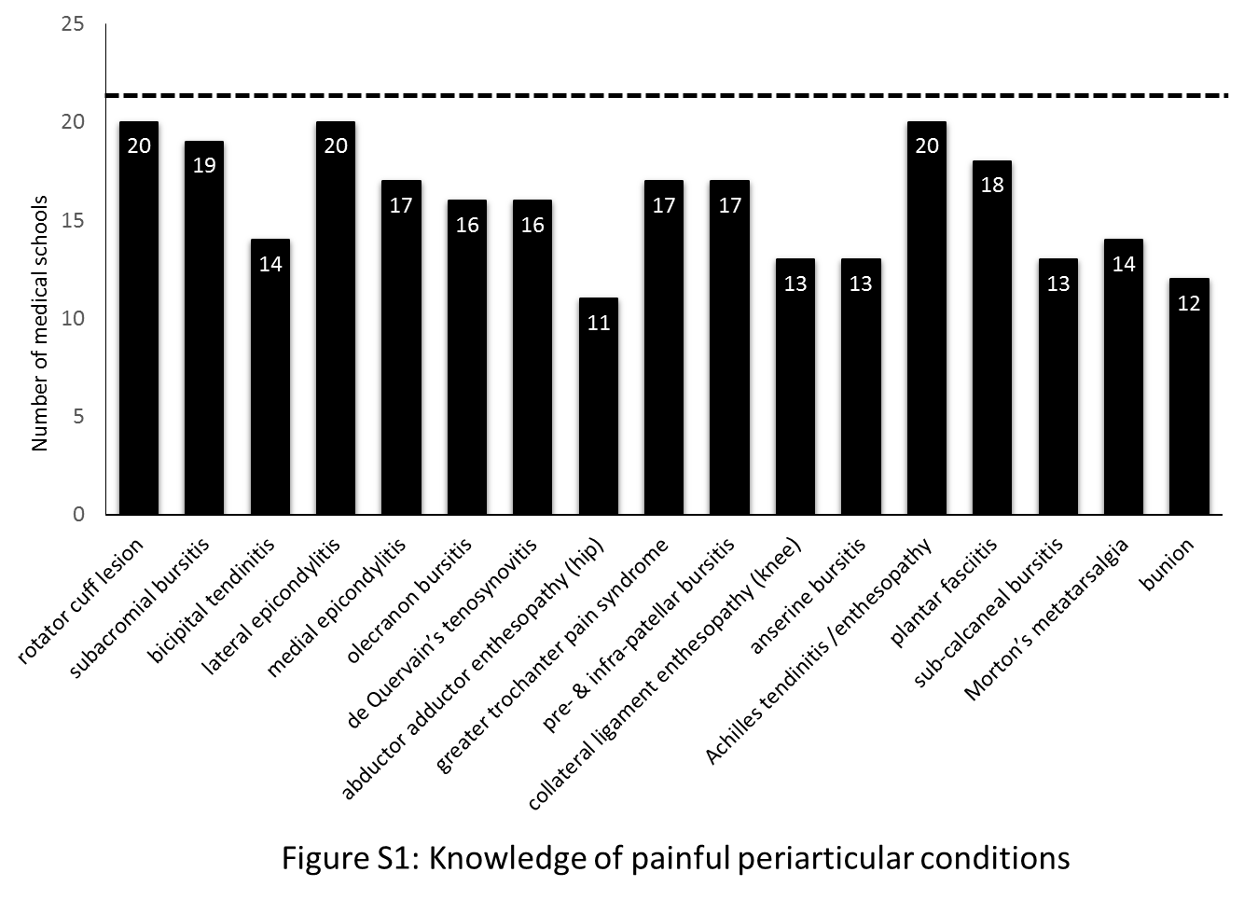

Figure S1: Curriculum content on painful peri-articular lesions

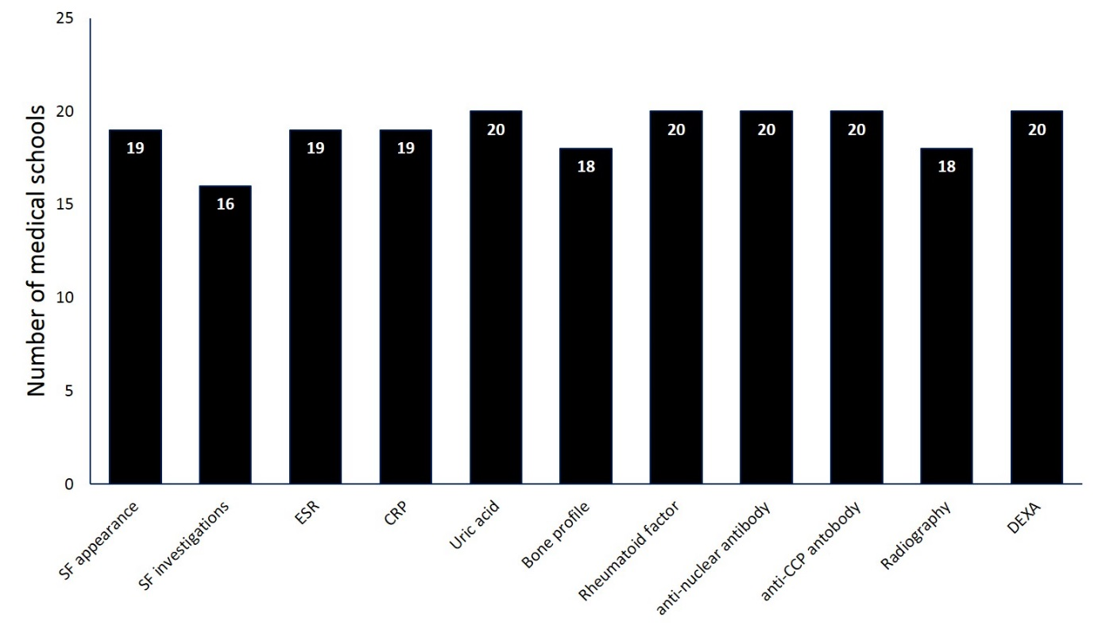Figure S2: Curriculum content on investigations relevant to musculoskeletal diseases. Musculoskeletal, salivary and vascular ultrasonography; and Magnetic Resonance Imaging (MRI), Computerised Tomography (CT) were included in the curriculum of three, one, and one; and two and one schools, respectively.

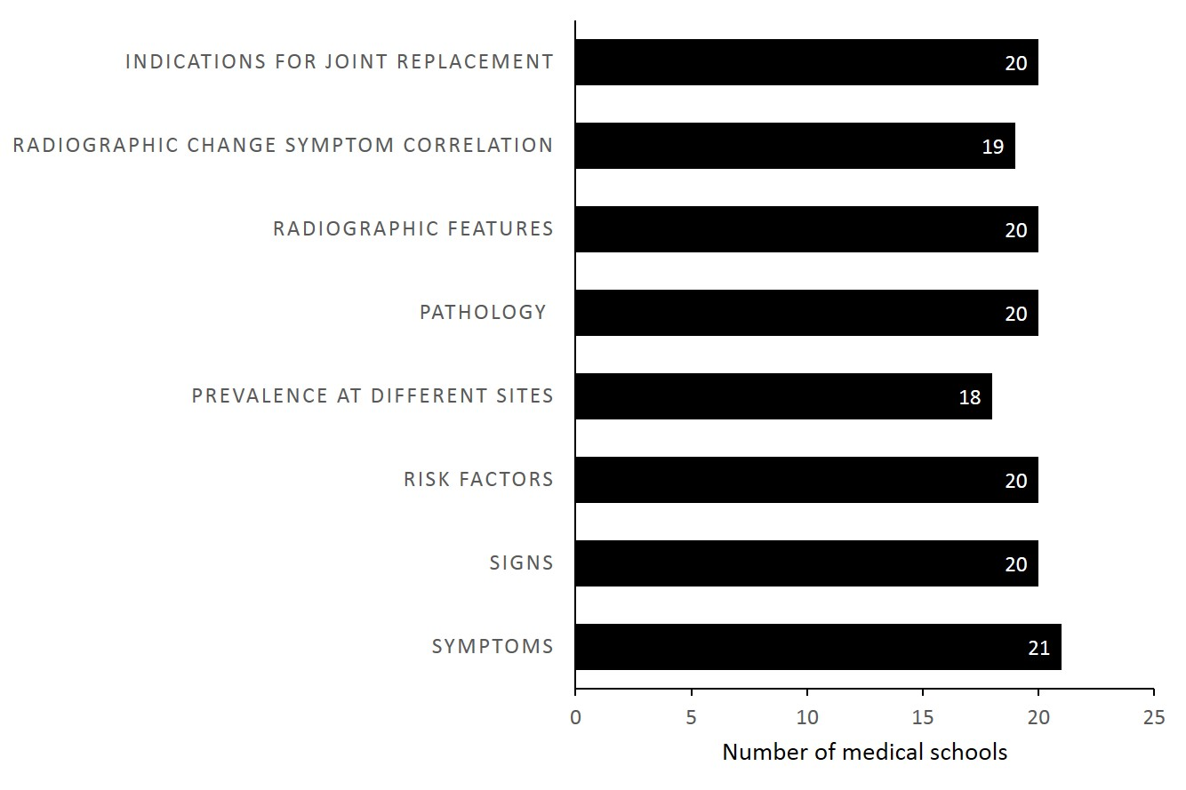Figure S3: Curriculum content on osteoarthritis
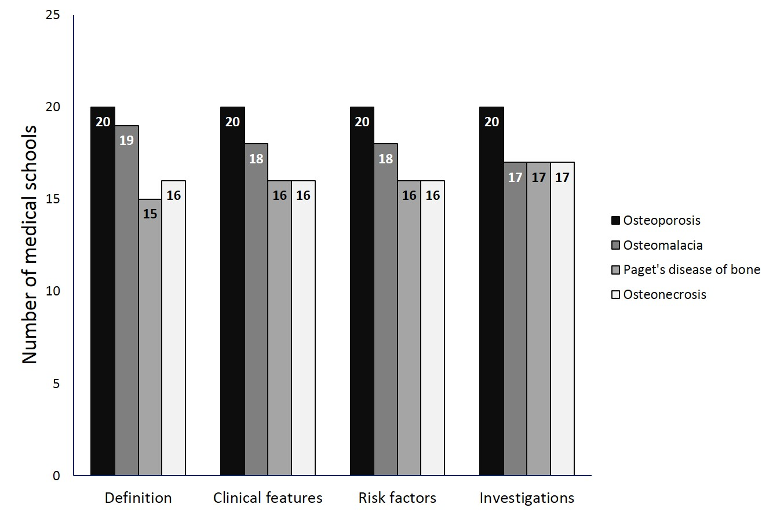
Figure S4: Curriculum content on metabolic bone diseases
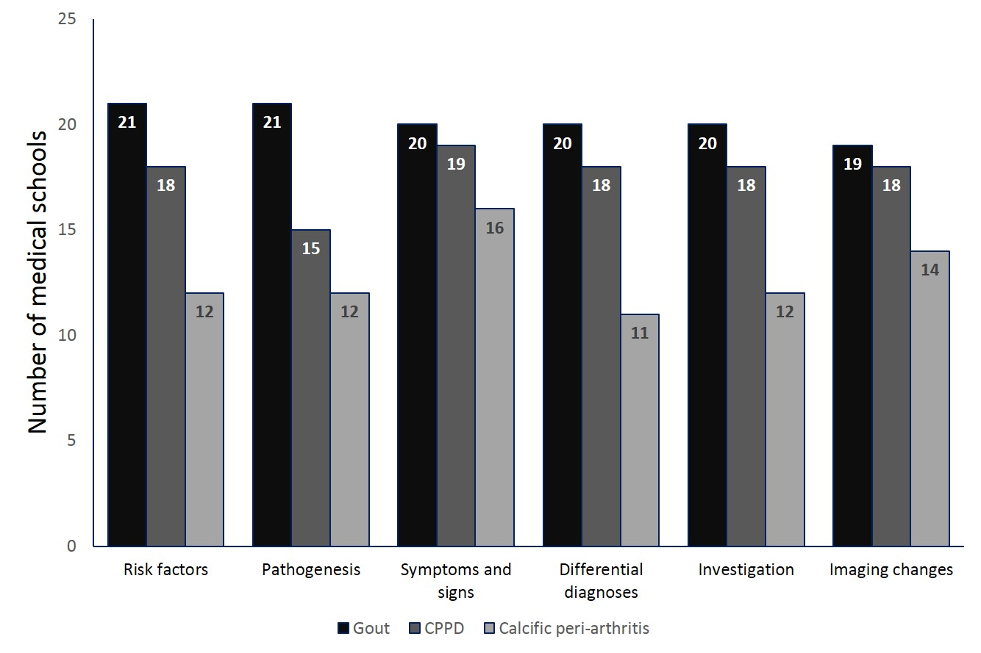
Figure S5: Curriculum content on microcrystalline arthropathies

