Figure S1. Key Inclusion and Exclusion Criteria of MEASURE 1 and MEASURE 2 Studies
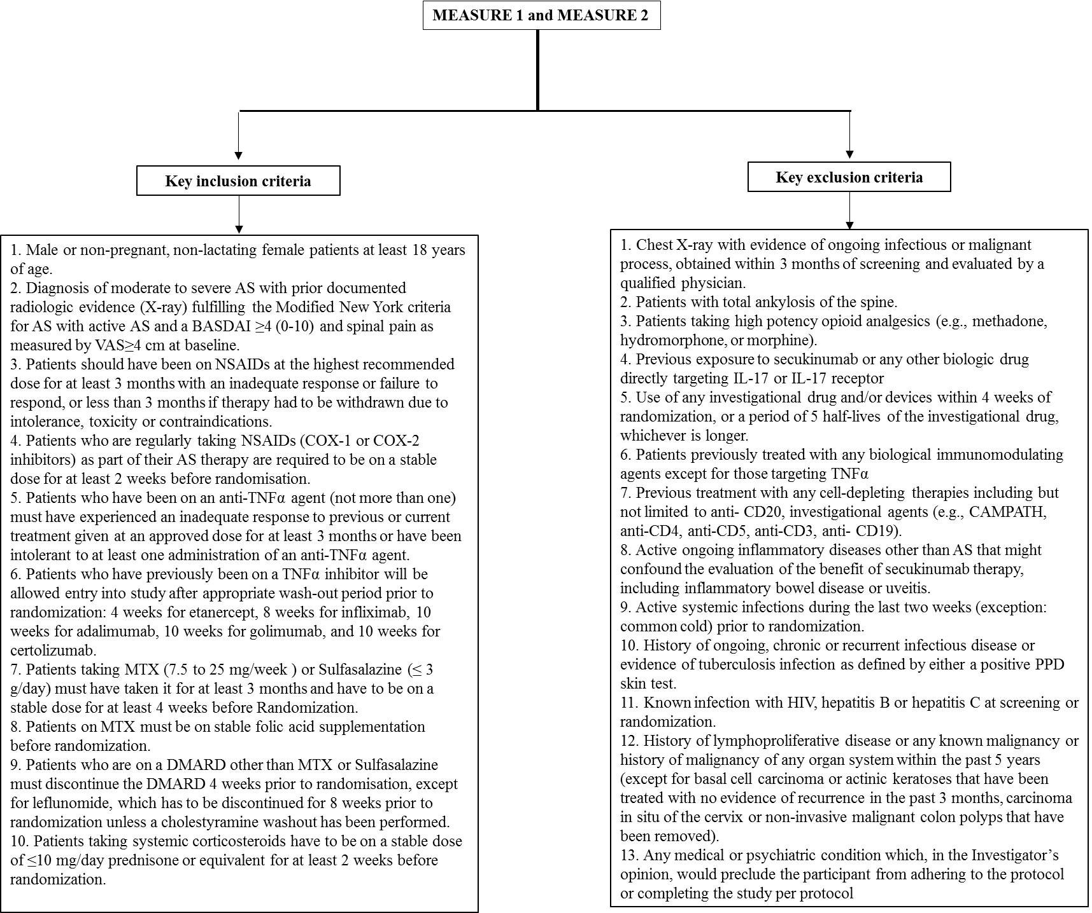
Table S1. Clinical Efficacy in Normal or Different Levels of Elevated Baseline CRP at Weeks 16 and 156

 |  | Normal baseline CRP (<5 mg/L) |  | Elevated baseline CRP
 |  |  |  | ≥5 to <10 mg/L |  | ≥10 to <15 mg/L |  | ≥15 mg/L
 | Week | Pooled secukinumab  150 mg  (N = 72) | Pooled placebo  (N = 71) | Pooled secukinumab  150 mg  (N = 38) | Pooled placebo  (N = 31) | Pooled secukinumab  150 mg  (N = 19) | Pooled  placebo  (N = 31) | Pooled secukinumab  150 mg  (N = 68) | Pooled placebo  (N = 62)
ASAS20, % | 16 | 56.9§ | 28.2 | 42.1 | 32.3 | 68.4§ | 29.0 | 73.5* | 27.4
 | 156 | 61.3 | – | 65.0 | – | 82.8 | – | 85.0 | –
ASAS40, % | 16 | 34.7† | 7.0 | 31.6 | 16.1 | 42.1 | 22.6 | 48.5* | 11.3
 | 156 | 42.4 | - | 50.0 | – | 76.4 | – | 67.9 | –
BASDAI, mean change from baseline | 16 | −2.2† | −1.0 | −1.5 | −0.7 | −2.8† | −0.6 | −2.8* | −0.6
 | 156 | −2.7 | – | −2.8 | – | −3.6 | – | −3.6 | –
BASDAI50, % | 16 | 27.8§ | 7.0 | 34.2 | 19.4 | 42.1§ | 6.5 | 41.2* | 8.1
 | 156 | 40.4 | – | 56.1 | – | 75.5 | – | 58.5 | –
ASDAS  inactive disease, % | 16 | 19.4‡ | 4.2 | 21.1 | 6.5 | 26.3 | 0 | 8.8 | 1.6
 | 156 | 28.9 | – | 28.5 | – | 16.9 | – | 15.1 | –
ASAS PR, % | 16 | 12.5 | 2.8 | 23.7‡ | 3.2 | 15.8 | 3.2 | 11.8 | 4.8
 | 156 | 14.4 | – | 34.6 | – | 33.4 | – | 30.2 | –
*P < 0.0001; †P < 0.001; §P < 0.01; ‡P < 0.05 versus placebo; missing values were imputed as non-response at Week 16. MI and MMRM data presented at Week 156 included n = 56 in normal baseline CRP group and n = 32, 18, and 53 in elevated baseline CRP ≥5 to <10 mg/L, ≥10 to <15 mg/L, and ≥15 mg/L groups, respectively. For BASDAI, LS mean change from baseline was presented using MMRM at Weeks 16 and 156. ASAS, Assessment of SpondyloArthritis international Society criteria; ASDAS, Ankylosing Spondylitis Disease Activity Score; BASDAI, Bath Ankylosing Spondylitis Disease Activity Index; CRP, C-reactive protein; LS, least squares; MI, multiple imputation; MMRM, mixed-effect model repeated measures; N, number of patients included in this pooled study at Week 16; n, number of patients in this pooled study at Week 156

