A randomised, double-blind, Phase III study comparing the infliximab biosimilar, PF-06438179/GP1111, with reference infliximab: Efficacy, safety and immunogenicity from Week 30 to Week 54
Rieke Alten,¹ Bogdan Batko,² Tomas Hala,³ Hideto Kameda,⁴ Sebastiao C. Radominski,⁵ Vira Tseluyko,⁶ Goran Babic,⁷ Carol Cronenberger,⁸ Sarah Hackley,⁹ Muhammad Rehman,¹⁰ Oliver von Richter,⁷ Min Zhang,¹¹ and Stanley Cohen¹²

SUPPLEMENTARY MATERIAL

Adverse events leading to treatment discontinuation excluded by programming cut-off
Two patients in the PF-SZ-IFX/PF-SZ-IFX group were diagnosed with latent tuberculosis after the Week 54 programming cut-off and were thus excluded from the Treatment Period 2 (TP2) safety analyses. Both cases were Grade 2 and were considered non-serious by the investigator; one case was considered to be related to study drug and one case to be unrelated to study drug. In both patients the study drug was discontinued permanently and no treatment for latent tuberculosis was recorded prior to TP2 database lock; however, both patients received isoniazid.
Table S1 Secondary efficacy endpoints at Weeks 30 and 54 (TP2 ITT population)
 | PF-SZ-IFX/  PF-SZ-IFX  (N=280) | Ref-IFX/  Ref-IFX  (N=143) | Ref-IFX/  PF-SZ-IFX  (N=143)
Patients with good/moderate/none EULAR response (%)
Week 30  Week 54 | 35.7 / 46.1 / 18.2  42.1 / 38.9 / 10.4 | 32.9 / 54.6 / 12.6  37.1 / 39.2 / 14.0 | 32.9 / 51.1 / 15.4  35.0 / 43.4 / 11.2
Patients achieving DAS28-CRP remission* (%)
Week 30  Week 54 | 22.5  28.2 | 20.3  23.1 | 17.5  20.3
Patients achieving ACR/EULAR remission† (%)
Week 30  Week 54 | 10.7  15.0 | 10.5  12.6 | 5.6  9.1
Mean change from baseline in swollen joint counts
Week 30  Week 54 | –11.3  –12.7 | –10.3  –11.0 | –11.8  –13.1
Mean change from baseline in tender joint counts
Week 30  Week 54 | –14.8  –16.8 | –15.0  –16.7 | –16.8  –18.2
Mean change from baseline in hs-CRP, mg/L
Week 30  Week 54 | –12.7  –12.2 | –10.2  –6.9 | –16.0  –15.2
*DAS28-CRP remission defined as DAS28-CRP score <2.6.
†Patients were considered to be in ACR/EULAR remission when scores on the tender joint count, swollen joint count, hs-CRP (mg/dL) and patient global assessment (0–10 scale) were all ≤1 (Boolean definition) or the simplified disease activity score was ≤3.3.
ACR, American College of Rheumatology; DAS28-CRP, disease activity score in 28 joints based on high-sensitivity C-reactive protein; EULAR, European League Against Rheumatism; hs-CRP, high sensitivity C-reactive protein; ref-IFX, European reference infliximab; ITT, intent-to-treat; PF-SZ-IFX, PF-06438179/GP1111; TP2, Treatment Period 2.

Table S2 Pre-dose trough serum drug concentration (ng/mL) versus time summary (TP2 PK population)
 | PF-SZ-IFX/PF-SZ-IFX |  |  | Ref-IFX/Ref-IFX |  |  | Ref-IFX/PF-SZ-IFX
 | All | ADA negative | ADA positive* | All | ADA negative | ADA positive* | All | ADA negative | ADA positive*
Week 30
N | 278 | 123 | 155 | 143 | 55 | 88 | 142 | 53 | 89
NALQ | 161 | 121 | 40 | 69 | 53 | 16 | 82 | 53 | 29
Median  (P5, P95) | 428.5  (0, 7381) | 3082  (408, 10050) | 0  (0, 1559) | 0  (0, 4757) | 1975  (109, 6376) | 0  (0, 1033) | 621.5  (0, 6361) | 3572  (920, 9479) | 0  (0, 2440)
Mean (CV) | 1801 (154) | 3658 (85) | 326.8 (346) | 1083 (163) | 2567 (79) | 156.0 (314) | 1819 (132) | 3998 (59) | 521.4 (225)
Week 38
N | 272 | 122 | 150 | 136 | 52 | 84 | 133 | 50 | 83
NALQ | 152 | 120 | 32 | 61 | 50 | 11 | 68 | 47 | 21
Median  (P5, P95) | 462  (0, 7931) | 3350  (500, 10770) | 0  (0, 1297) | 0  (0, 5926) | 2814  (266, 6887) | 0  (0, 517) | 102  (0, 6221) | 3021  (0, 8361) | 0  (0, 1671)
Mean (CV) | 1855 (155) | 3794 (83) | 278.7 (406) | 1208 (159) | 2990 (70) | 104.5 (375) | 1620 (149) | 3579 (68) | 440.2 (331)
Week 54
N | 248 | 114 | 134 | 125 | 49 | 76 | 125 | 47 | 78
NALQ | 145 | 112 | 33 | 57 | 46 | 11 | 67 | 47 | 20
Median  (P5, P95) | 549.5  (0, 8521) | 3033  (248, 11580) | 0  (0, 3269) | 0  (0, 6097) | 2598  (0, 11890) | 0  (0, 821) | 184  (0, 7608) | 3573  (630, 10260) | 0  (0, 1863)
Mean (CV) | 2075  (195) | 3513  (90) | 851.8  (508) | 1823  (335) | 4485  (205) | 106.7  (316) | 1734  (157) | 4232  (71) | 229.4  (277)
EOT/ET
N | 16 | 3 | 13 | 14 | 4 | 10 | 11 | 4 | 7
NALQ | 4 | 3 | 1 | 4 | 4 | 0 | 6 | 4 | 2
Median  (P5, P95) | 0  (0, 5418) | 1376  (988, 5418) | 0  (0, 212) | 0  (0, 1346) | 650  (332, 1346) | –  (–, –) | 117  (0, 28380) | 1423  (501, 28380) | 0  (0, 4515)
Mean (CV) | 499.6 (275) | 2594 (95) | 16.31 (361) | 212.7 (190) | 744.5 (58) | – (–) | 3305 (255) | 7932 (172) | 661.7 (257)
The TP2 PK population included all patients who received study treatment in TP2, had no protocol deviations influencing the PK assessment, and provided at least 1 drug concentration measurement during TP2. Summary statistics are not presented if number of observations above LLOQ (NALQ)=0. Summary statistics were calculated by setting concentration values below the LLOQ to 0. The LLOQ is 100 ng/mL. One patient in the ref-IFX/PF-SZ-IFX group was excluded from the PK summary statistics at Week 54 due to a dispensing error at Week 46.
*Patients with at least 1 post-dose sample that tested positive during TP1, regardless of the pre-dose ADA status, or a newly ADA positive subject in TP2.
ADA, anti-drug antibody; CV, coefficient of variation; EOT, end of treatment; ET, early termination; LLOQ, lower limit of quantification; N, number of observations; NALQ, number of observations above LLOQ; P5, 5th percentile; P95, 95th percentile; PF-SZ-IFX, PF-06438179/GP1111; PK, pharmacokinetic; ref-IFX, European reference infliximab; TP2, Treatment Period 2.

Figure S1 REFLECTIONS B537-02 study design

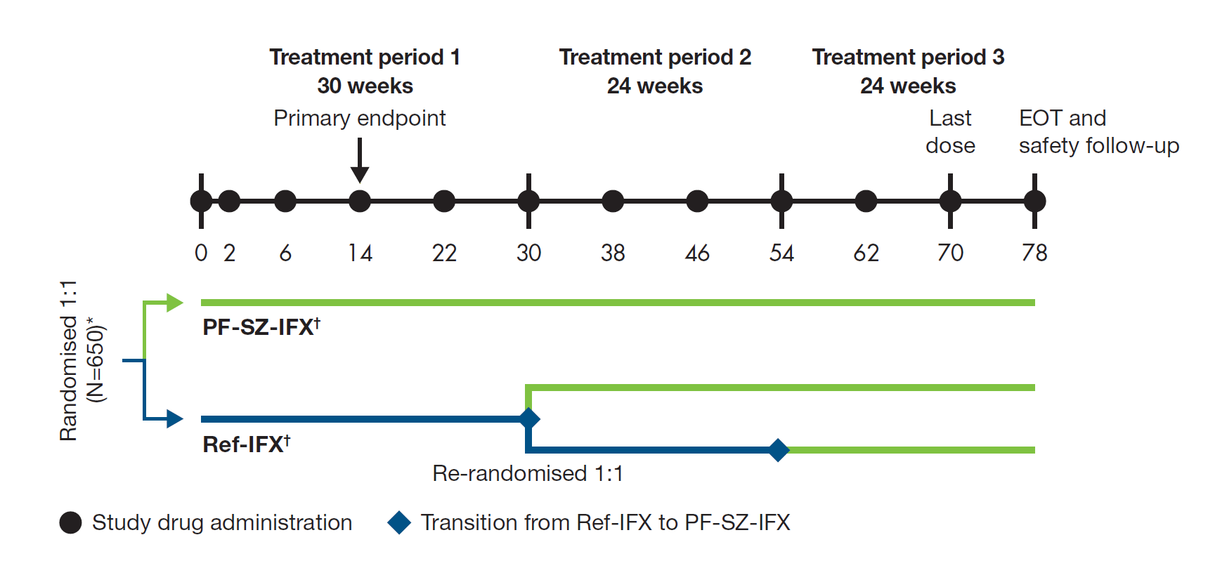
EOT, end of treatment; ref-IFX, European reference infliximab; PF-SZ-IFX, PF-06438179/GP1111.
This figure was originally published in Cohen S, et al. A randomized controlled trial comparing PF-06438179/GP1111 (an infliximab biosimilar) and infliximab reference product for treatment of moderate to severe, active rheumatoid arthritis despite methotrexate therapy. Arthritis Res Ther 2018;20:155, and has been reproduced with minor changes under the terms of the Creative Commons Attribution 4.0 International License (http://creativecommons.org/licenses/by/4.0/).
Figure S2 Mean change in HAQ-DI scores during TP2 (TP2 ITT population)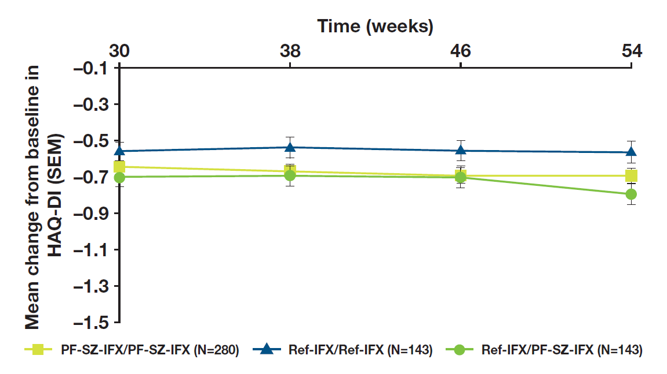
HAQ-DI, Health Assessment Questionnaire - Disability Index; ref-IFX, European reference infliximab; ITT, intent-to-treat; PF-SZ-IFX, PF-06438179/GP1111; SEM, standard error of the mean; TP2, Treatment Period 2.

