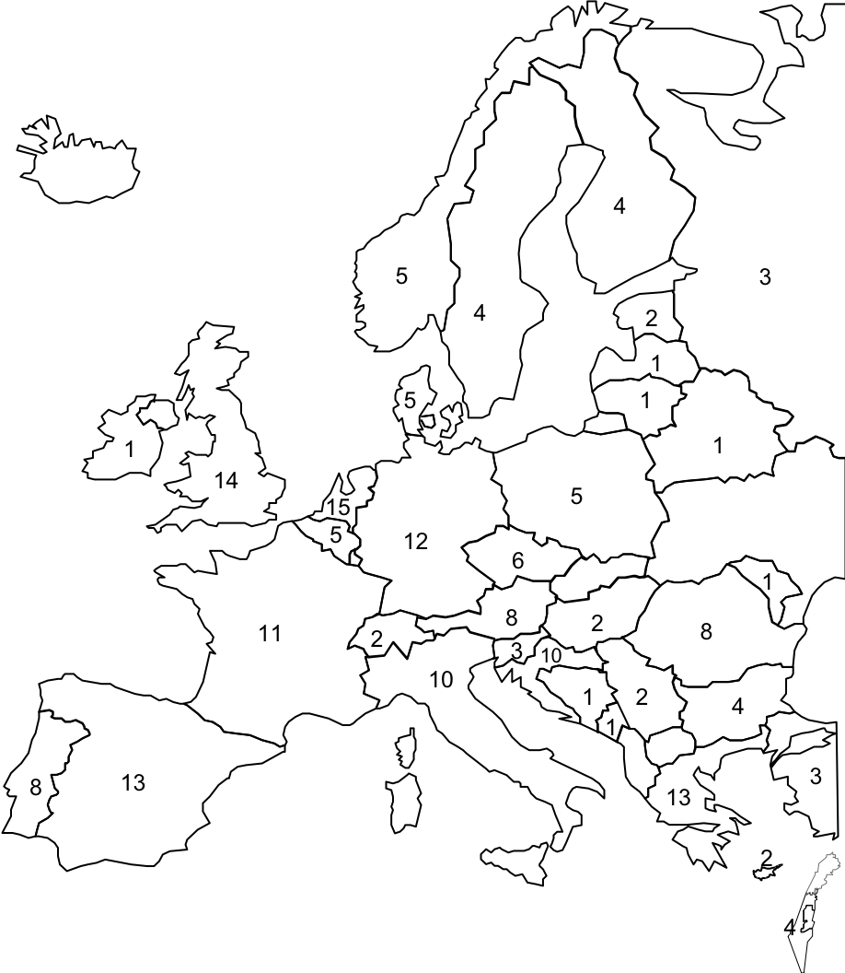

Supplementary figure 1. Distribution of respondents according to country

