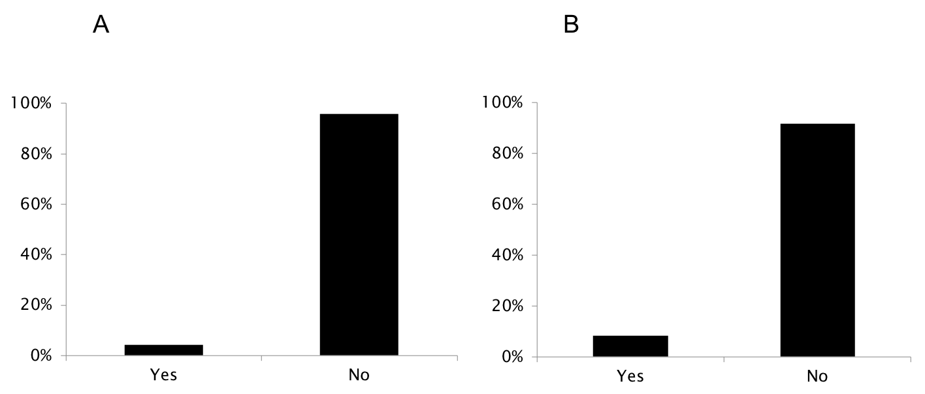

Supplementary Figure 12. Training opportunities in computed tomography among member countries of the European League Against Rheumatism participating in the survey. A: inclusion of training in computed tomography in the national training curricula for rheumatologists; B: training course(s) in computed tomography organized by the national rheumatology society

