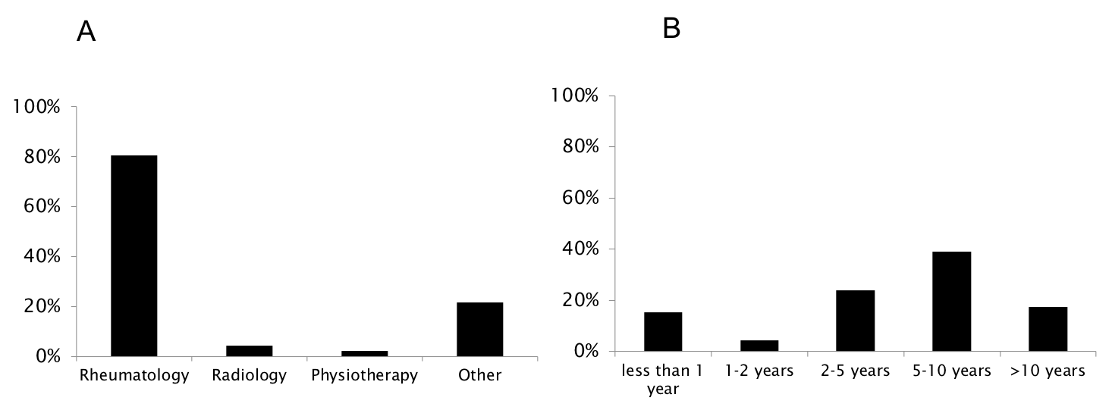

Supplementary Figure 13. Characteristics of respondents participating in the survey on positron emission tomography. A: specialty; B: years of experience performing positron emission tomography;

