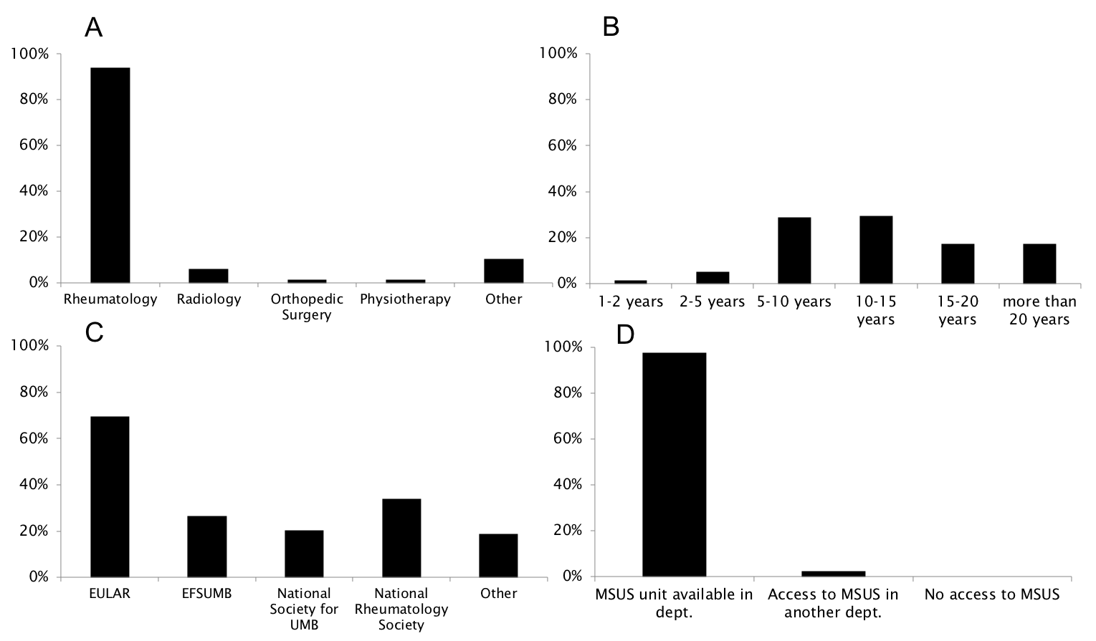

Supplementary Figure 2. Characteristics of respondents participating in the survey on musculoskeletal ultrasound. A: specialty; B: years of experience performing musculoskeletal ultrasound; C: certification in musculoskeletal ultrasound; D: availability of musculoskeletal ultrasound for the rheumatology department; EFSUMB: European Federation of Societies for Ultrasound in Medicine and Biology; EULAR: European League Against Rheumatism; MSUS: musculoskeletal ultrasound; UMB: Ultrasound in Medicine and Biology

