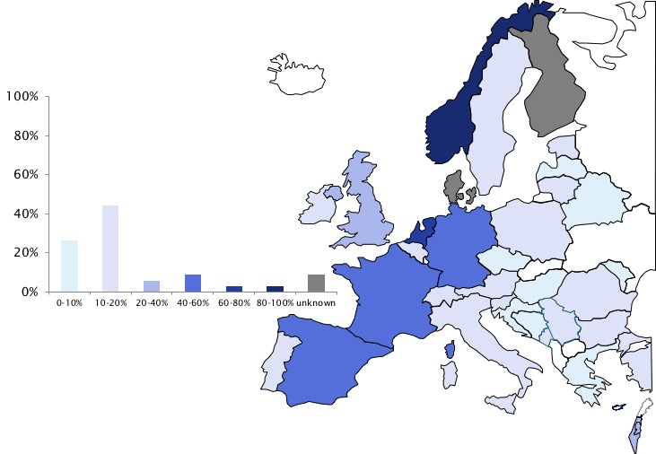

Supplementary Figure 5. Percentage of rheumatologists performing ultrasound-guided musculoskeletal interventions among member countries of the European League Against Rheumatism

