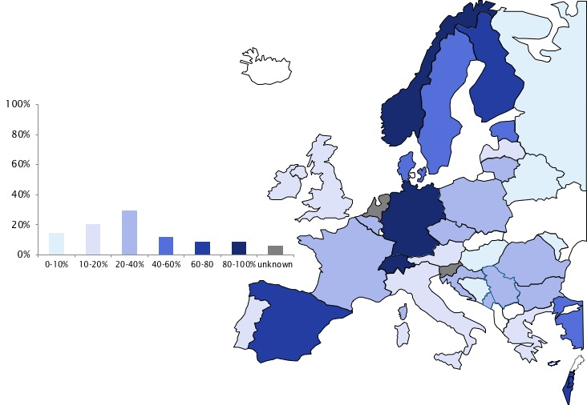

Supplementary Figure 6. Percentage of rheumatologists trained in musculoskeletal ultrasound among member countries of the European League Against Rheumatism

