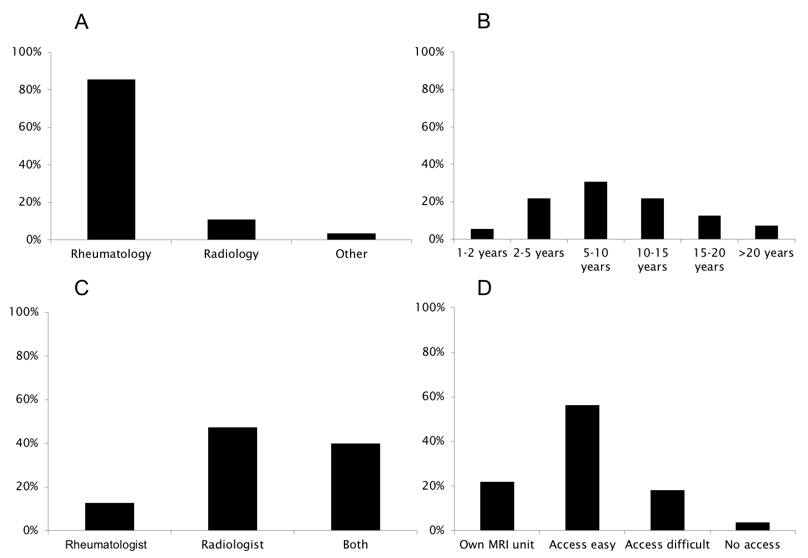
Supplementary Figure 7. Characteristics of respondents participating in the survey on magnetic resonance imaging. A: specialty; B: years of experience performing magnetic resonance imaging; C: specialist reading the magnetic resonance imaging image; D: availability of magnetic resonance imaging for the rheumatology department; MRI: magnetic resonance imaging

