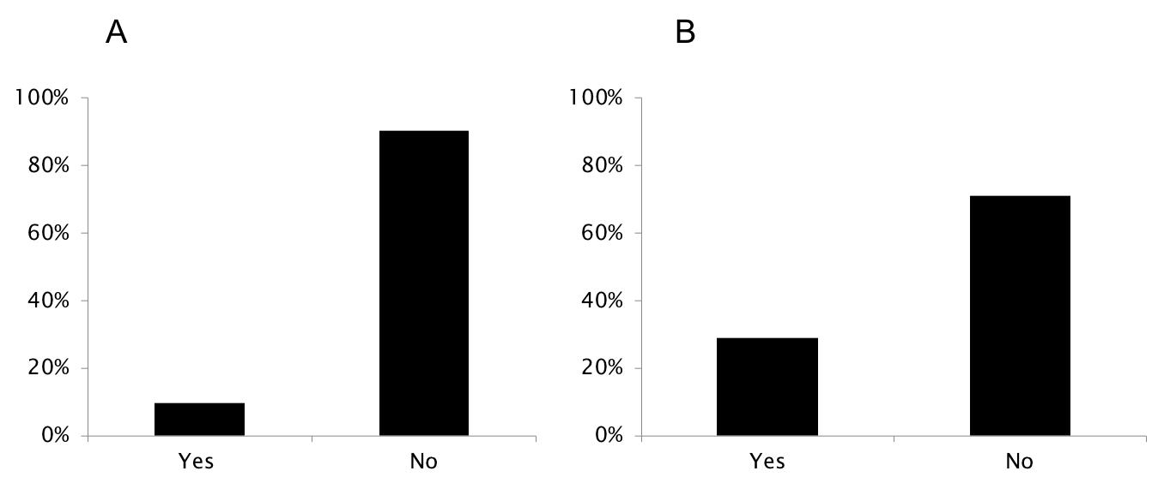

Supplementary Figure 9. Training opportunities in magnetic resonance imaging among member countries of the European League Against Rheumatism participating in the survey. A: inclusion of training in magnetic resonance imaging in the national training curricula for rheumatologists; B: training course(s) in magnetic resonance imaging organized by the national rheumatology society

