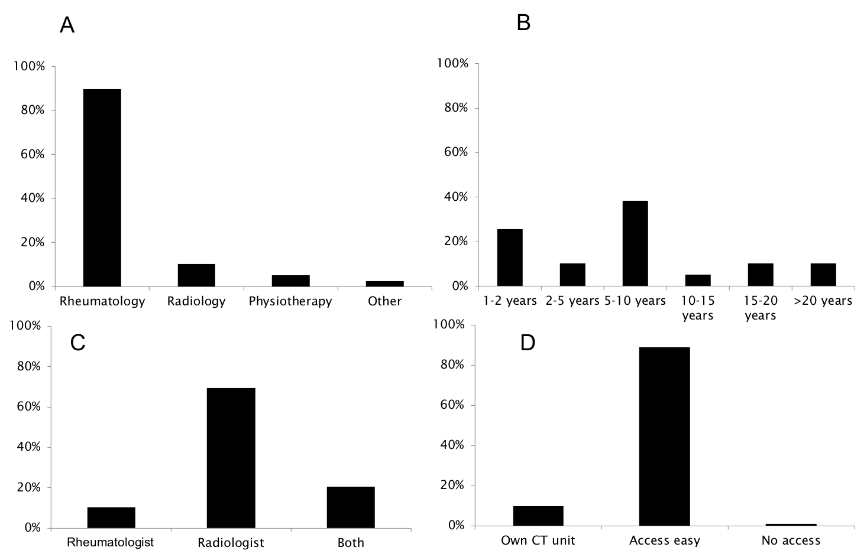

Supplementary Figure 10. Characteristics of respondents participating in the survey on computed tomography. A: specialty; B: years of experience performing computed tomography; C: specialist reading the computed tomography image; D: availability of computed tomography for the rheumatology department; CT: computed tomography

